Supplementary Materials

Supplementary Note 1: Instruction of RDmaster online platform

RDmaster is implemented as an online web tool (<http://rdmaster.nbscn.org/>) assisting differential diagnosis (DDX) of rare diseases (RDs). It supports multi-omics diagnosis and can capture diagnostically beneficial phenotypes (signs and symptoms) in the form of human-computer interaction. RDmaster consists of two main steps: clinical feature collection and dialogue diagnosis.

**Clinical Feature Collection Page:**

The procedure of RDmaster begins with an initial clinical report, mainly including sequencing file upload and phenotype information entry, as shown in Fig. S1a. Part 1 in Fig. S1a includes fields for patient age and gender. Part 2 in Fig. S1a is a file uploader for variant data in VCF format. Part 3 in Fig. S1a is a panel to collect and display the patient’s phenotype information.

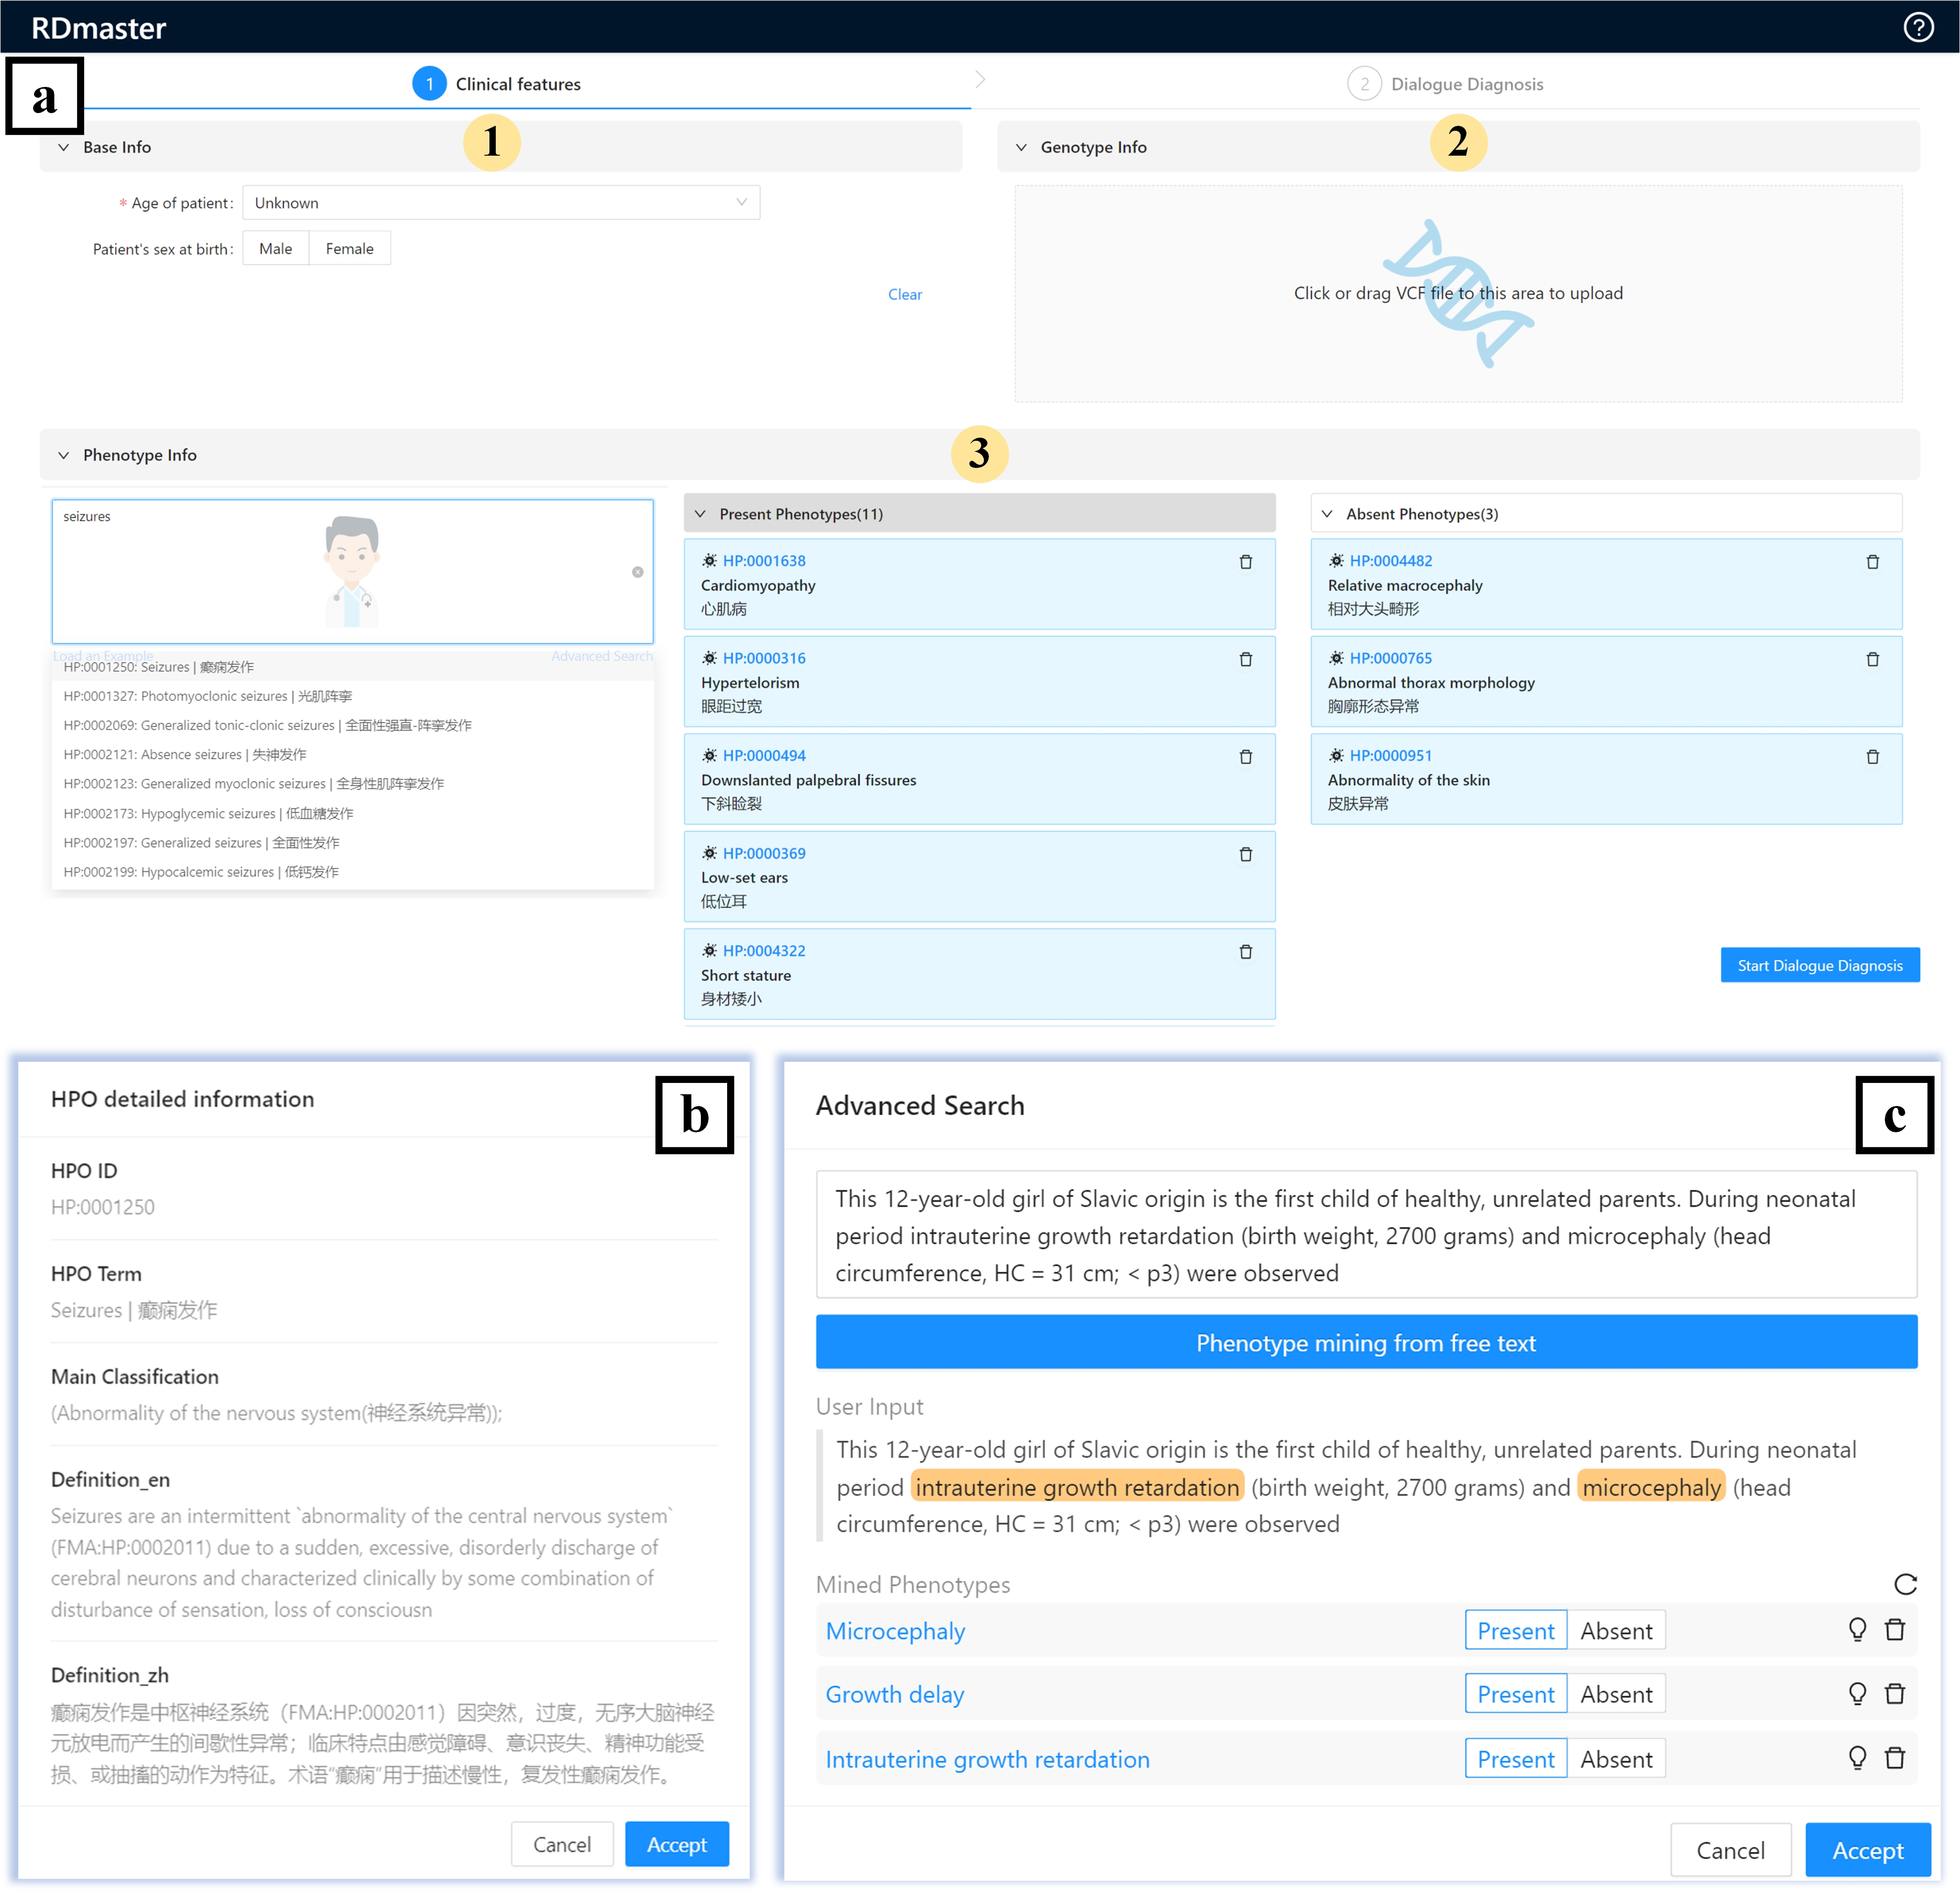

**Supplemental Fig. 1** Clinical feature collection step of RDmaster. **a** Clinical feature collection page. **b** Detailed information modal of selected HPO term. **c** Modal box for mining HPO term from free text.

Users can enter phenotypes in the input box and then select the HPO term in the pop-up character-matching list. Upon selection of an HPO term, a pop-up modal (Fig. S1b) displaying the details of this term can be confirmed by clinicians as a present phenotype of the patient. To facilitate the collection of phenotypes, the SciGraph was integrated to annotate user-provided free text with Human Phenotype Ontology (HPO) concepts. Users can click on "Advanced Search" to bring up the modal box for mining phenotype, as shown in Fig. S1b. Entered HPO terms can be flexibly organized by dragging and dropping them into categories of “Present Phenotypes” or “Absent Phenotypes” and can be deleted by clicking the trash icon.

Only the “Present Phenotypes” field is mandatory at this stage. If a VCF file is uploaded, a phenotype-genotype integrated diagnosis will be performed. If not, RDmaster will conduct a phenotype-driven diagnosis. Users can click on “Load an example” to load a test case. Upon completion of the initial report, users can proceed to the dialogue diagnosis step by clicking “Start Dialogue Diagnosis”.

**Dialogue Diagnosis Page:**

The UI of this phase is mainly divided into four module

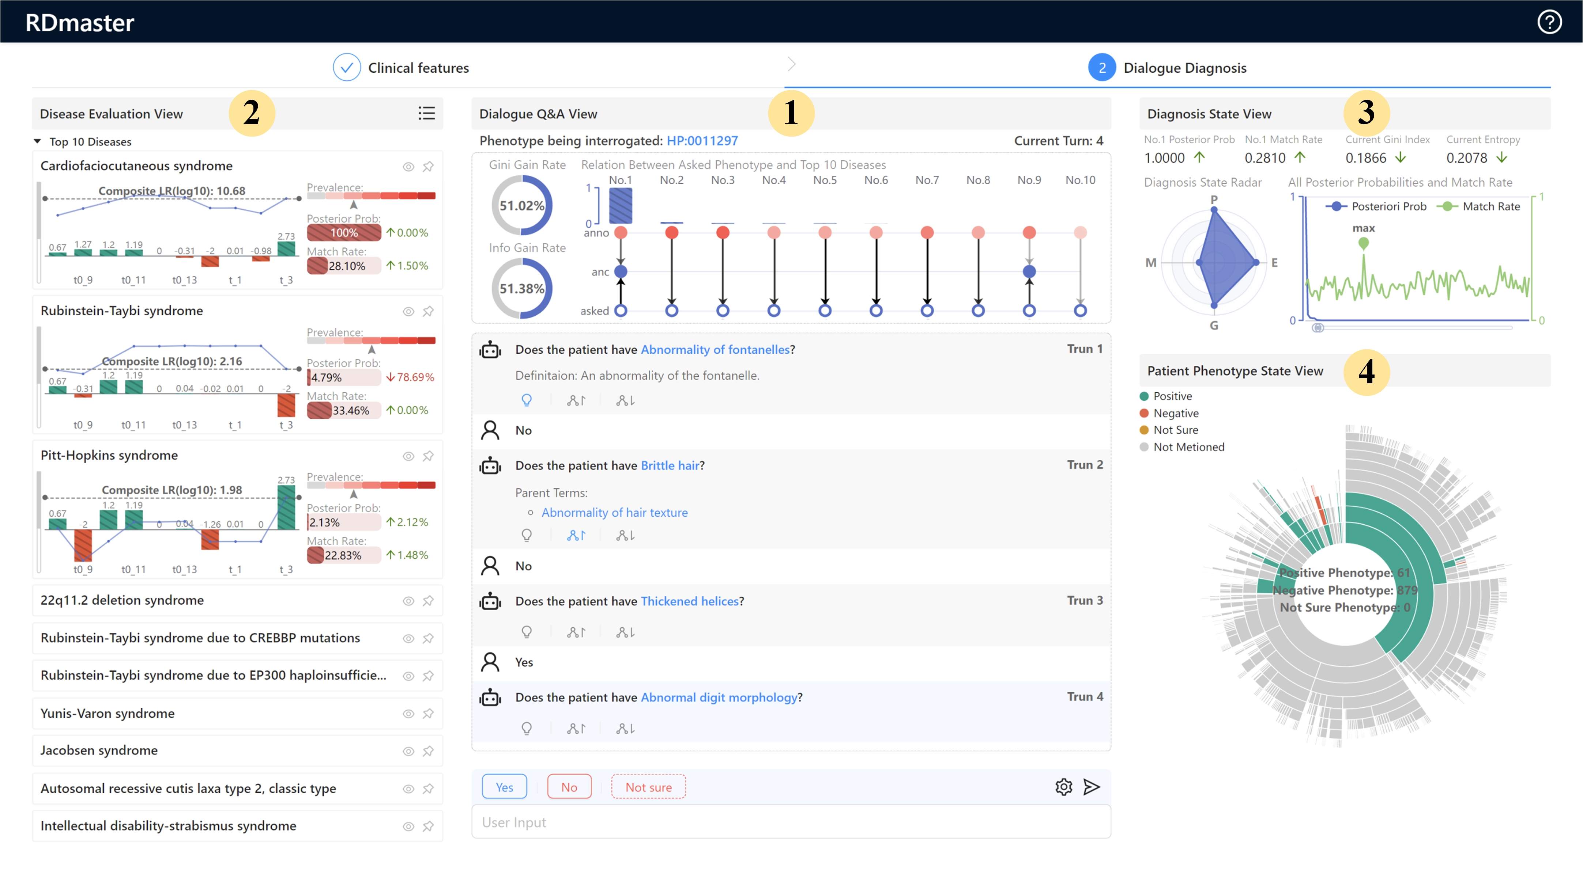

**Supplemental Fig. 2** Dialogue diagnosis step of RDmaster.

Dialogue Q&A module (Fig. S2, part 1). This is the core module for conducting phenotype-oriented Q&A dialogue. This module consists of three parts:

(i) The top-position box shows the reason for the current interrogated phenotype, mainly including its calculated expected gain (Gini gain and Information gain), the posterior probabilities of the top-10 ranked diseases (bar chart), and the semantic relationship between the interrogated phenotypes and top-10 ranked diseases (three-layer network, constructed based on HPO hierarchy). The contents of the three-layer network can be displayed by tooltips when the mouse hovers.

(ii) The middle-position box shows the dialogue content. Users can click on the icons to view the definition, parent terms, and child terms of interrogated phenotypes, as shown in Fig. S3.

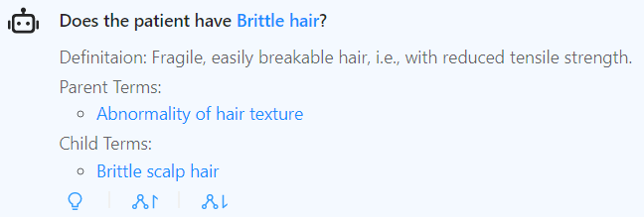

**Supplemental Fig. 3** Questions asked by the agent robot.

(iii) The bottom-position part is the user response box. Users can respond with “Yes”, “No”, or “Not sure” to the current interrogated phenotype, or can actively report symptoms, which will use the SciGraph to identify HPO terms from the entered text (Fig. S4). Users can click on the setting icon to select our dialog policy (calculate expected gain by AIGGI, AIGGI-P, or AIGGI-N).

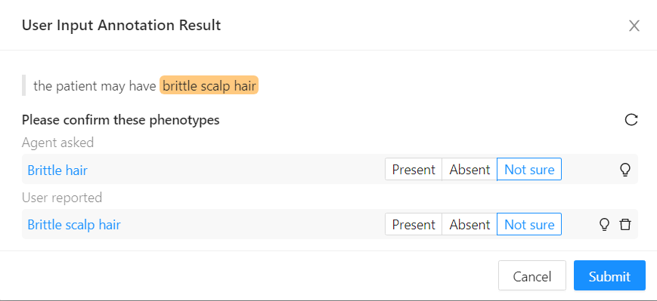

**Supplemental Fig. 4** Mining HPO terms from user input.

Disease evaluation module (Fig. S2, part 2). This module provides detailed phenotypic and genotypic (if a VCF file is uploaded) analysis results for the top-10 ranked diseases. Specifically, the analysis results mainly include the prior probability (evaluated by its point prevalence) and posterior probability of tested disease, the disease-patient phenotypic match ratio, and likelihood ratio scores of collected phenotypes and disease-causing genes. The phenotype name of each histogram in this panel can be displayed by tooltips when the mouse hovers. Click on the eye icon to view the detailed phenotypic analysis results of the disease, as shown in Fig. S5. If a VCF file is uploaded and the disease is a rare genetic disease, users can view the genetic analysis results of the disease by clicking on the genotype on the disease card, as shown in Fig. S6. Click on the button in the upper right corner of this panel to call up a posterior-probability ranked table of all candidate diseases, as shown in Fig. S7. This table supports a character-matching search for disease name and ORPHA code. Users can click the “Fixed” button to fix interesting diseases on the main page.

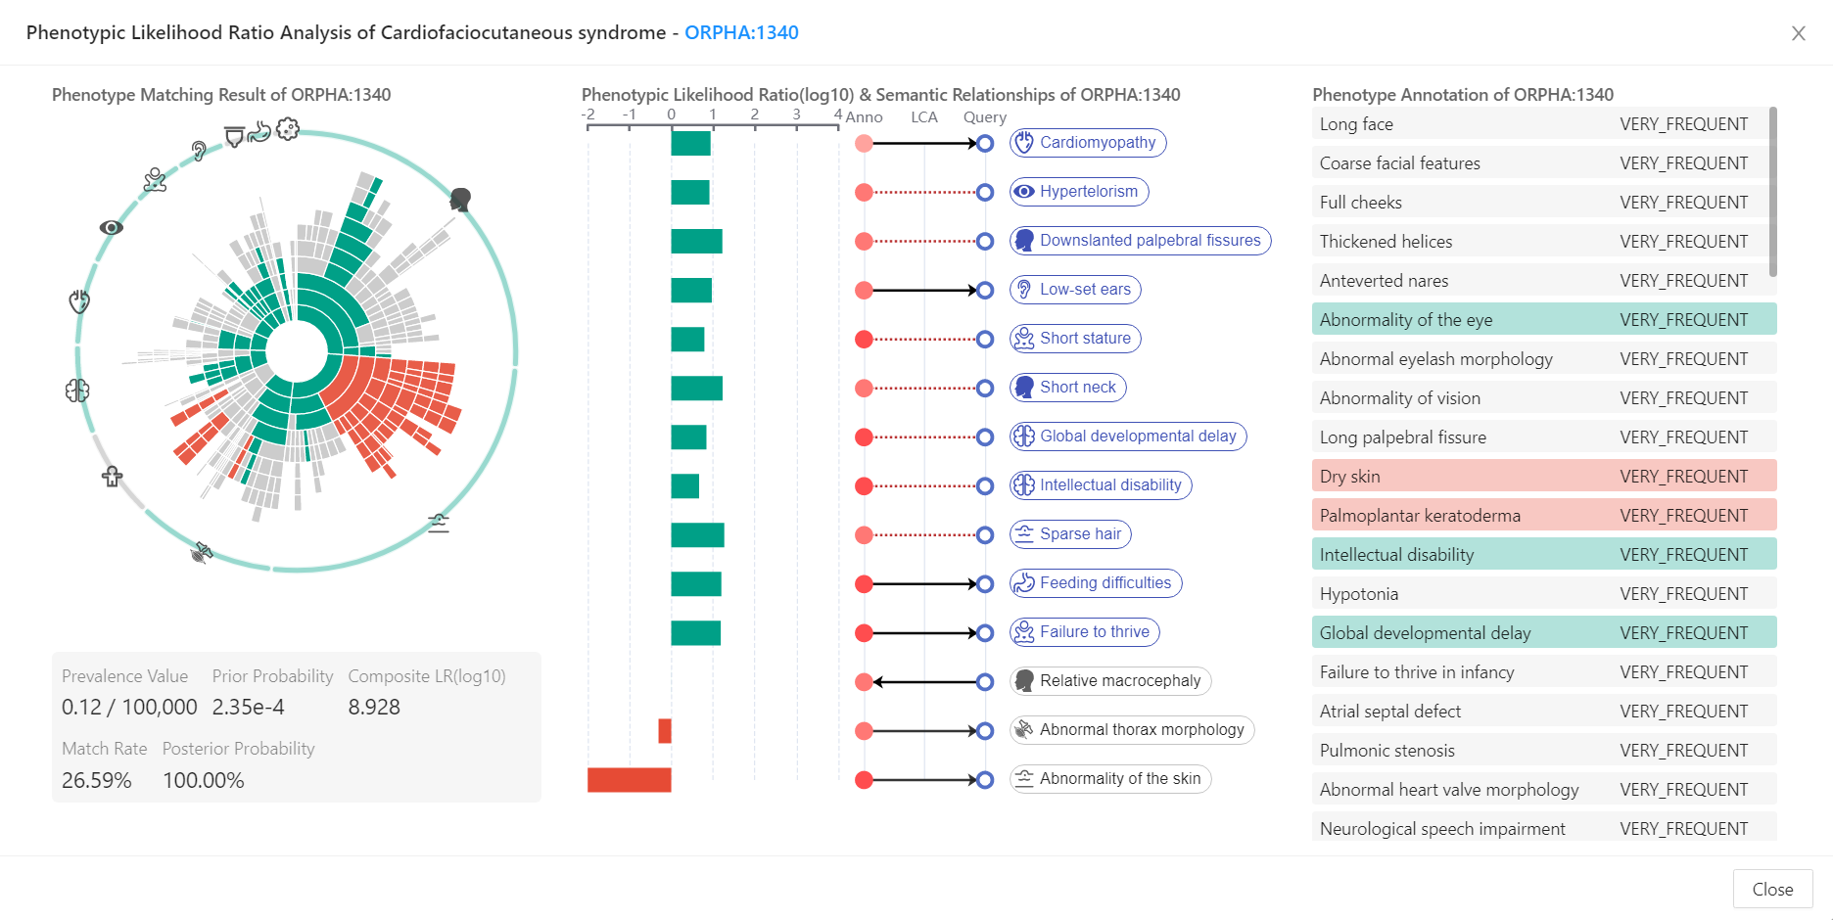

**Supplemental Fig. 5** Phenotypic likelihood ratio analysis of the selected disease.

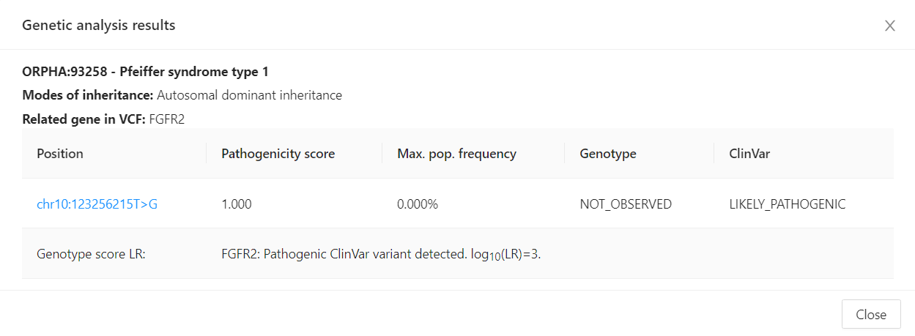

**Supplemental Fig. 6** Genetic analysis results of the selected diseases based on the uploaded VCF.

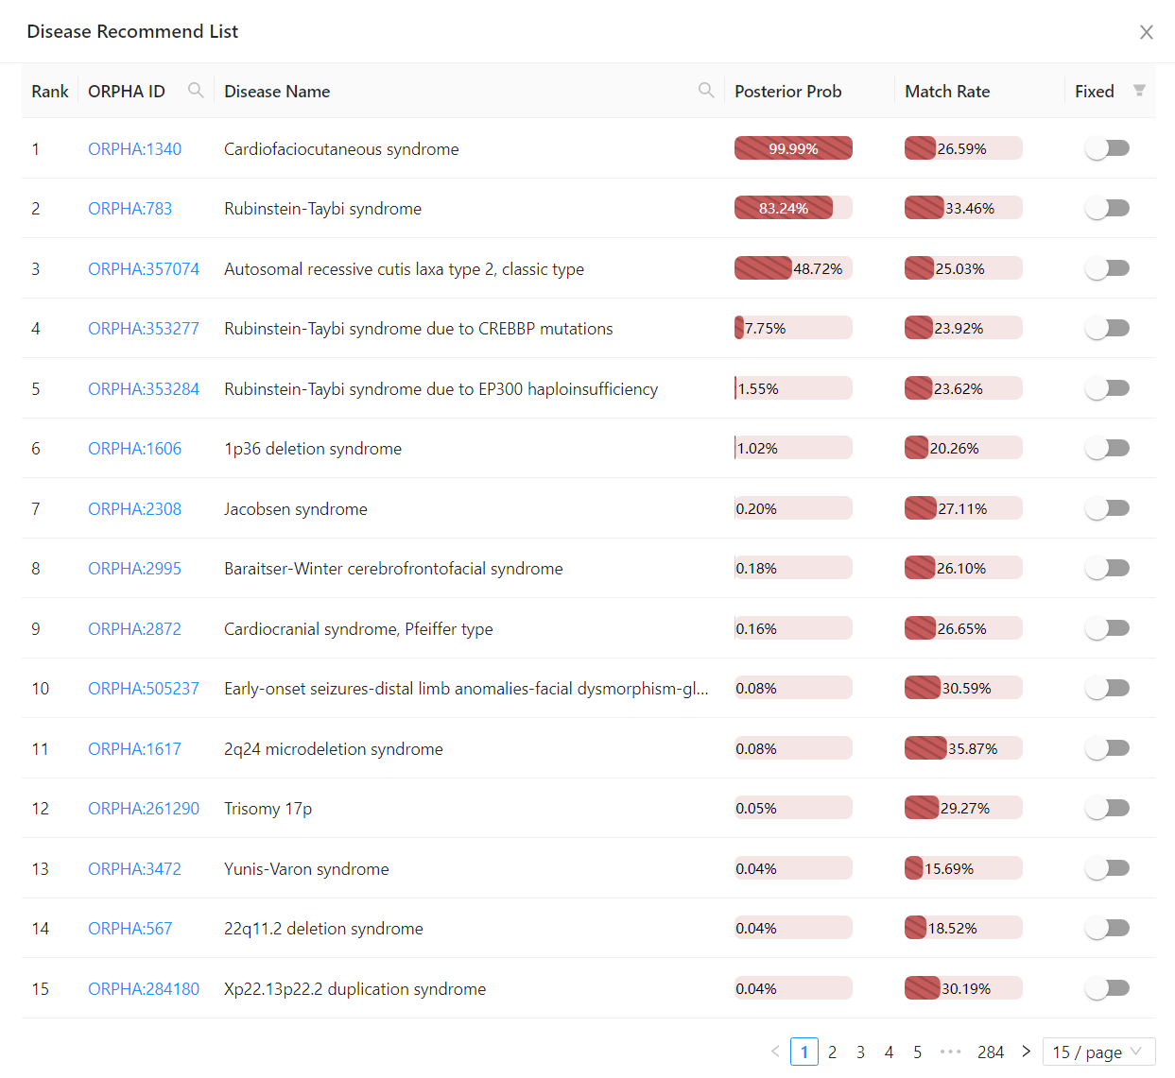

**Supplemental Fig. 7** Table of all candidate diseases ranked based on posterior probabilities.

Diagnostic state module (Fig. S2, part 3), which indicates the real-time diagnostic status, mainly includes a four-dimensional (the posterior probability and match ratio of top 1 disease, the entropy and Gini index calculated from posterior probability distribution of all tested diseases) radar chart, where a larger area represents a lower diagnostic uncertainty, and a line graph showing the posterior probabilities and phenotypic matching rates for all candidate diseases (order by posterior probabilities). When the first-ranked disease has a high posterior probability and is significantly better than other diseases, the area of the radar chart should be large enough for the user to make a final diagnosis.

Patient phenotypic state module (Fig. S2, part 4), mainly a sunburst chart of patient phenotype features drawn based on the HPO structure and annotation propagation rule. This chart renders all present phenotypes, absent phenotypes, and not-sure phenotypes in different colors.

Supplementary Note 2: Classification decision trees built on disease-phenotype associations

We constructed two classification decision trees (ID3 and CART) using *DecisionTreeClassifier* from *sklearn* package. Specifically, 9,087 disease-related phenotypes constituted the feature set, 4,257 rare diseases (RDs) were target variables, and disease-phenotype association scores with the annotated propagation rule applied were used as feature values being trained. The maximum depth of these two classification trees was set to 50 and two binary tree graphs of depth 5 were drawn using *pydotplus* package, as shown in Fig. S8 and Fig. S9. Results showed that the decision tree constructed based on information gain selects the most conditional discriminative phenotype at each node, e.g., its root node was *Abnormality of the musculature* (HP:0003011), which was associated with 2117 ORPHAs and not with the remaining 2140. This indicates that information entropy prefers to choose the feature that minimizes uncertainty at each node and thus performs better for messier data. The decision tree constructed based on the Gini index presents a significantly different strategy, e.g., it got the fastest diagnosis after only two decisions, which indicates that the Gini index was more effective in rapidly purifying candidates.

The process of executing a decision tree is similar to a clinical interview, in which a series of symptoms are judged to arrive at a final diagnosis. During the differential diagnosis process, when the physician is faced with multiple competing diagnoses, it is most effective to select the most discriminating symptom to interrogate, which can be calculated using the information gain, while when there are a few competing diagnoses, the Gini index can be used to improve the purity of the diagnosis and obtain a final diagnosis as quickly as possible. Taking inspiration from these two classic decision tree metric functions, we proposed an adaptive fusion metric, AIGGI, which combines the advantages of both metrics based on real-time diagnostic status and focuses on reducing uncertainty when diagnostic uncertainty is high, primarily using information gain, and quickly obtaining a diagnosis when diagnostic purity is high, mainly using Gini index.

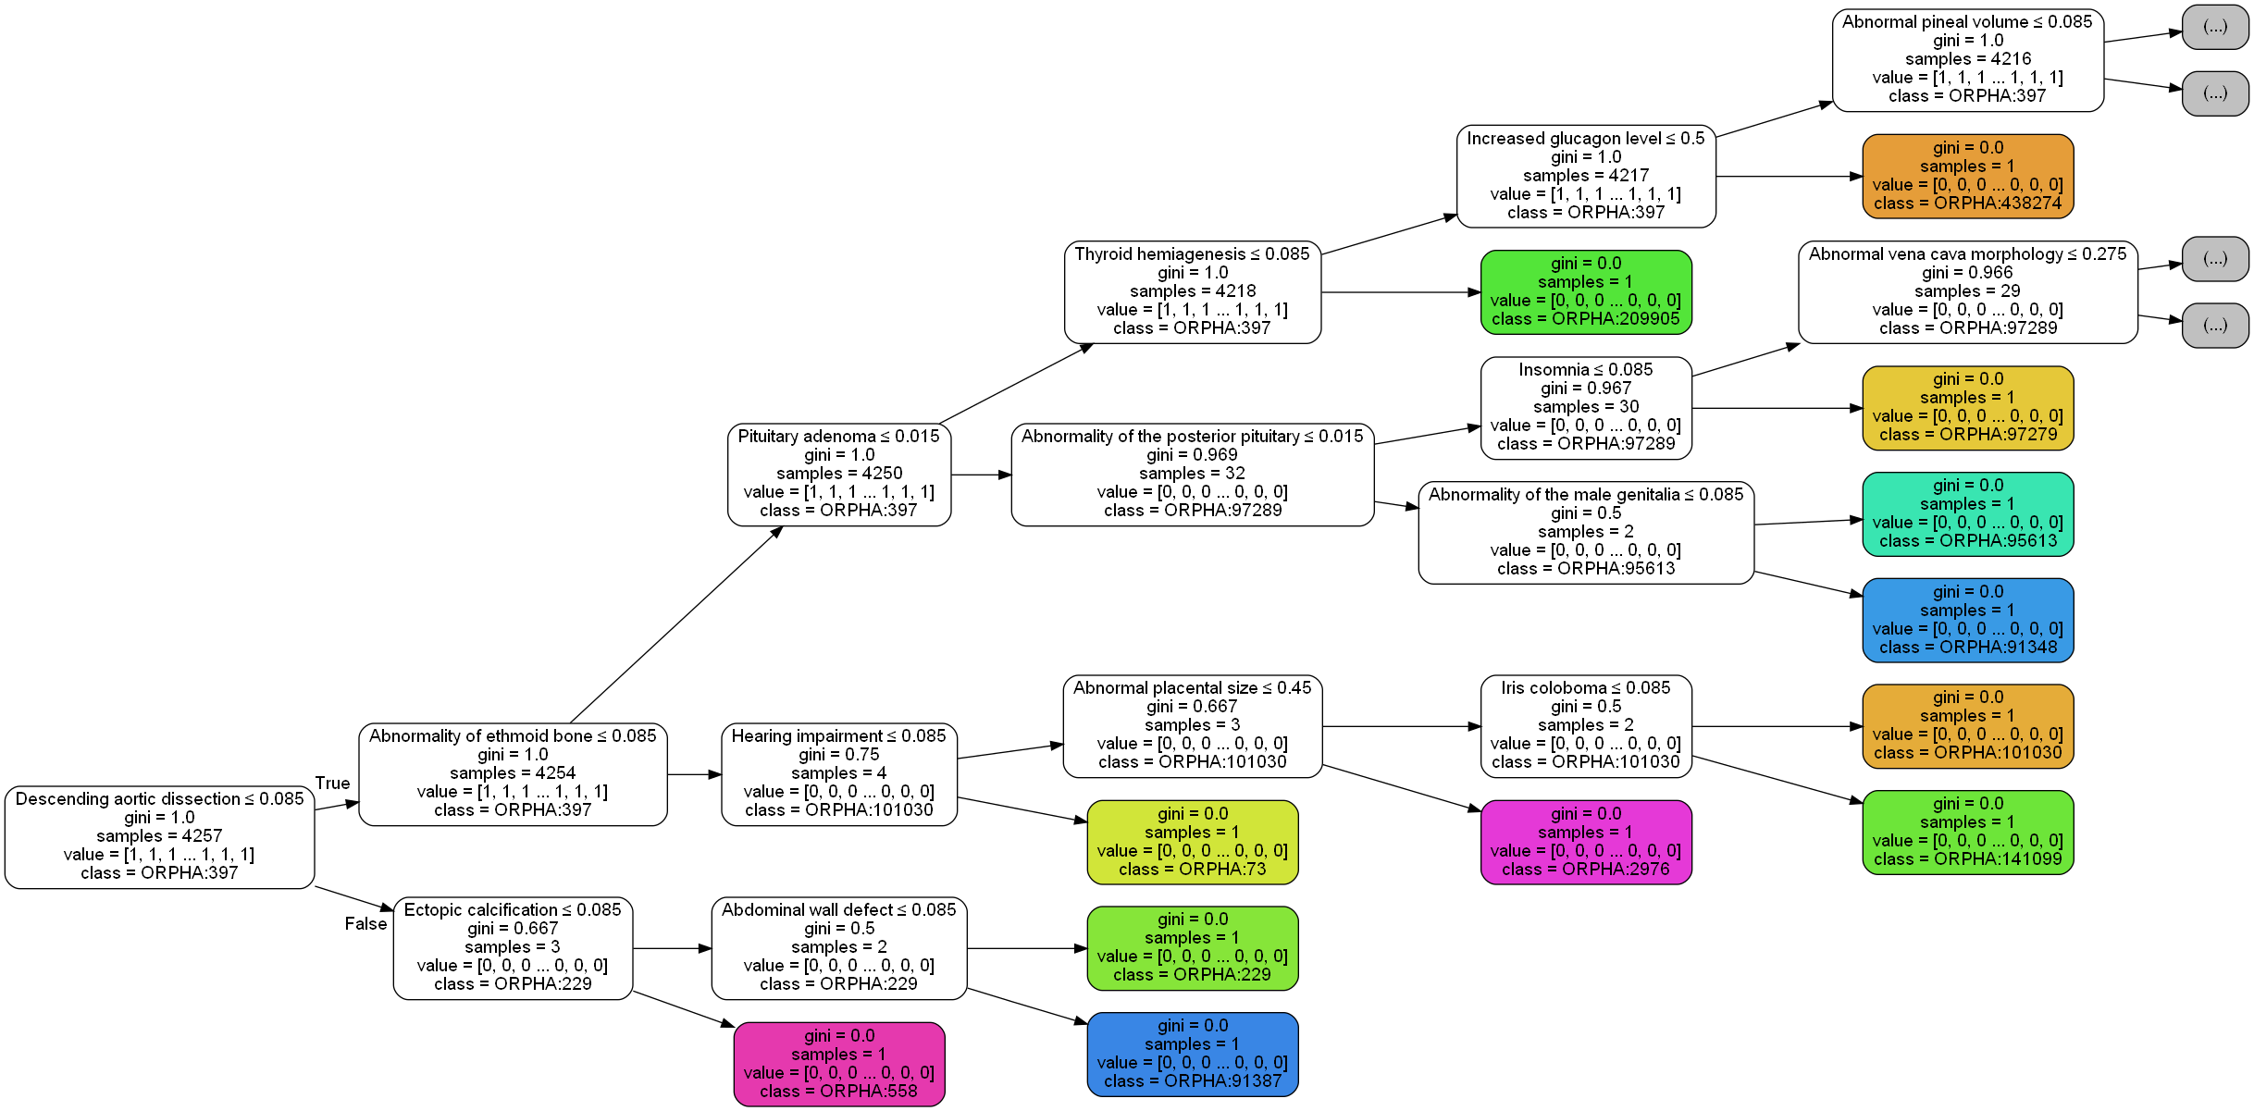

**Supplemental Fig. 8** Decision tree constructed based on Gini index

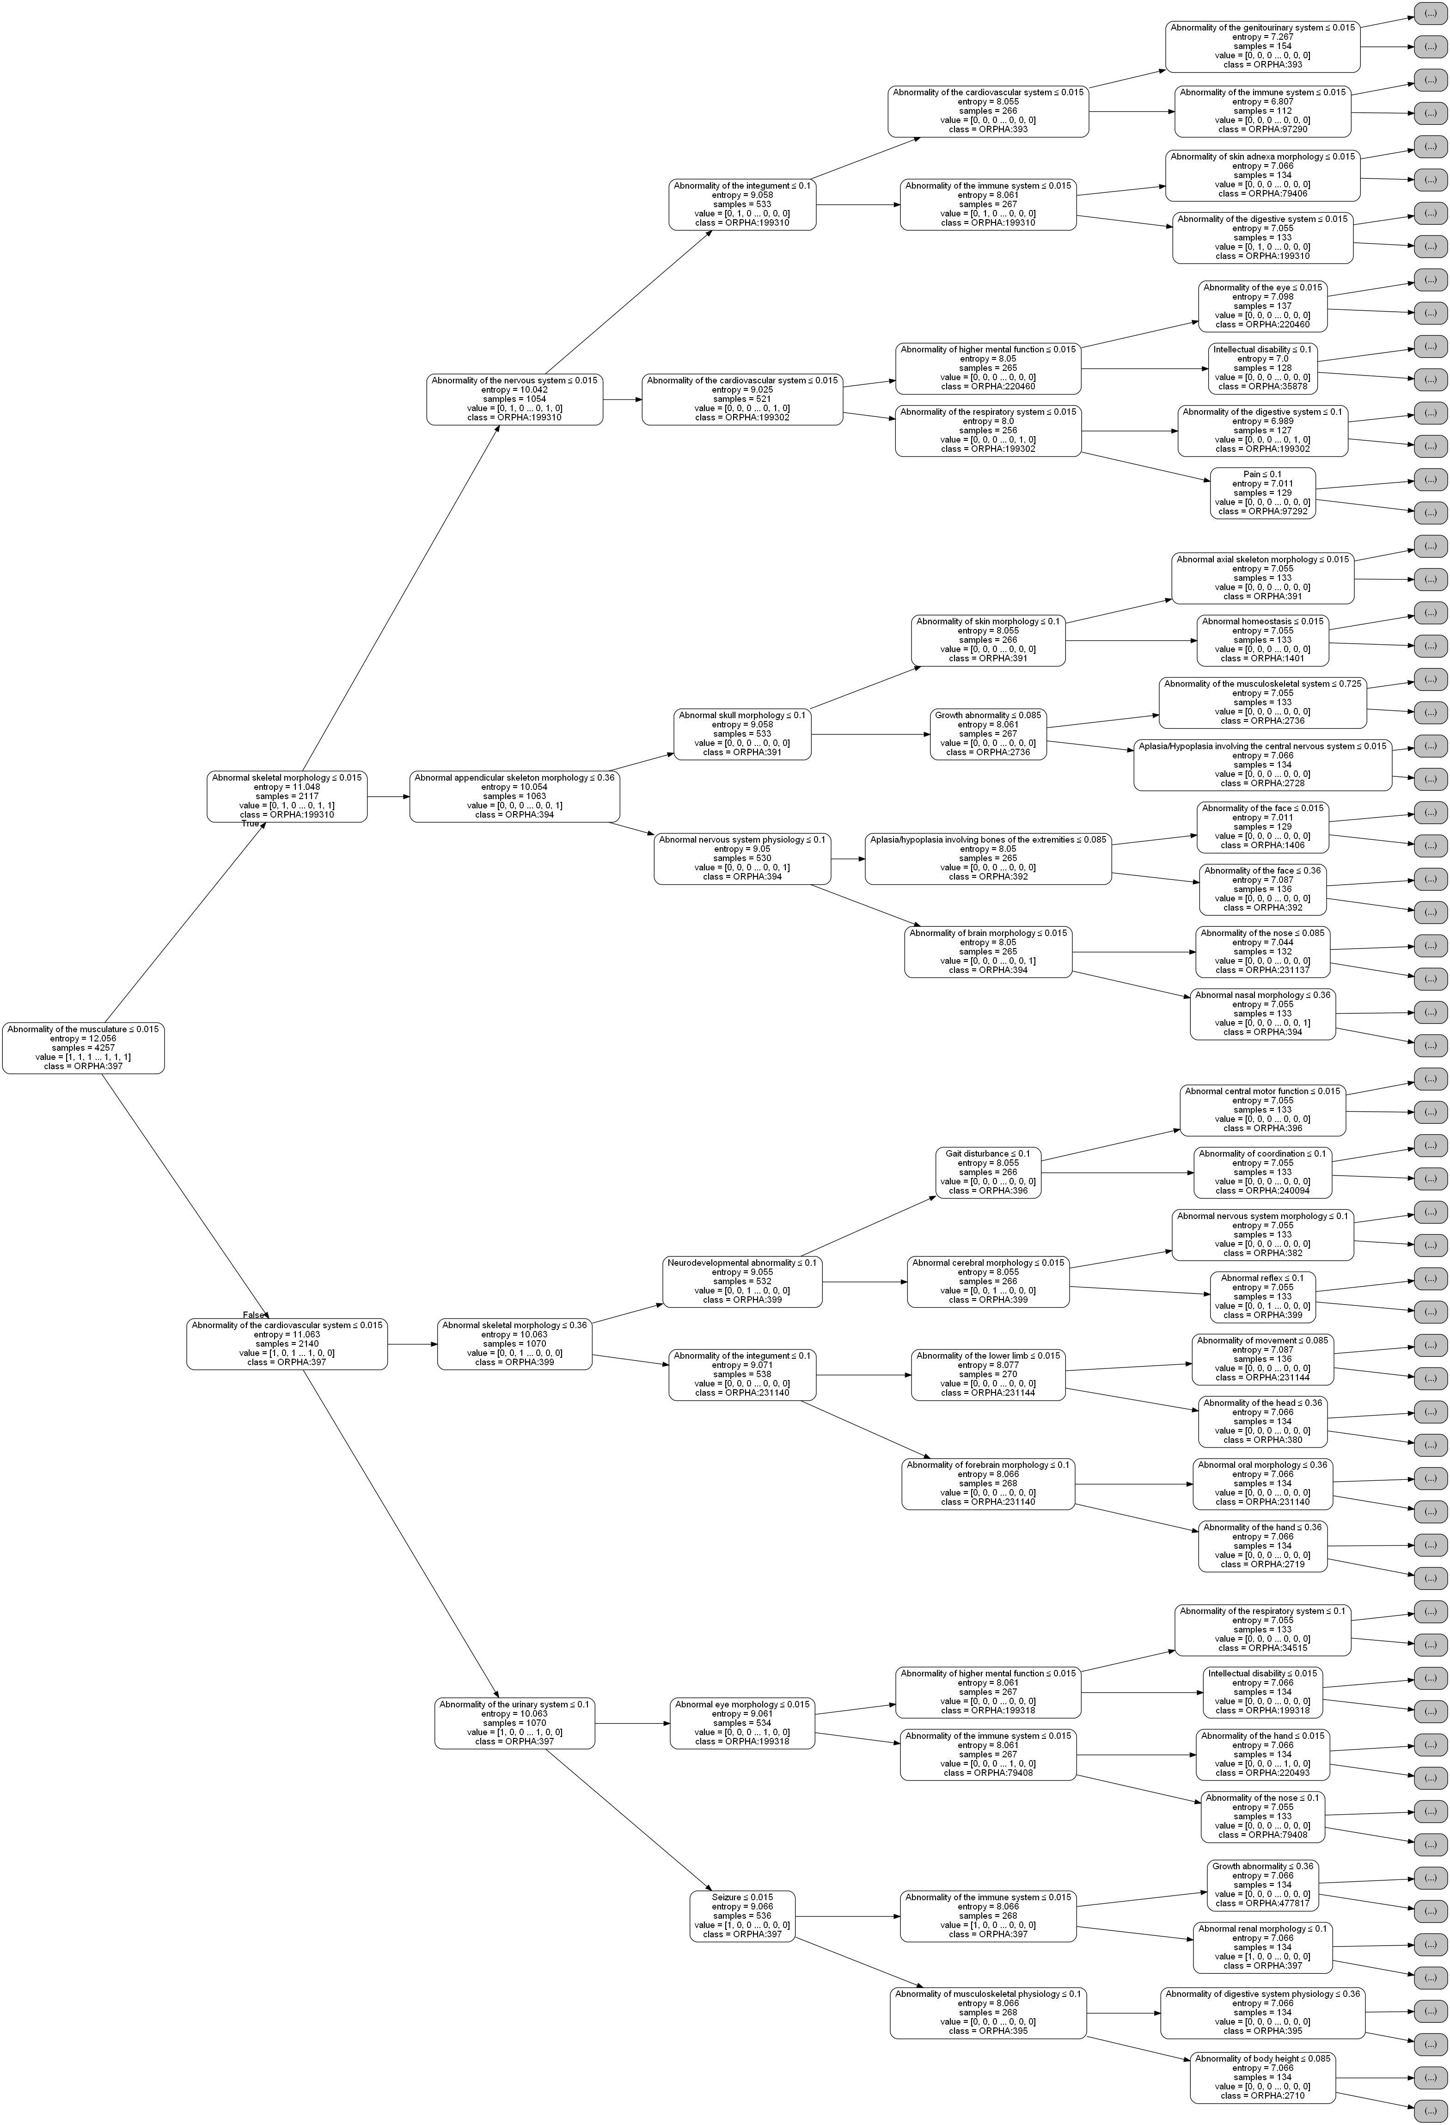

**Supplemental Fig. 9** Decision tree constructed based on information gain

Supplementary Note 3: Detailed analysis result of RDmaster's dialogue strategies

To evaluate RDmaster’s dialogue strategy, we simulated tens of thousands of cases according to HPO frequency annotations and randomly added inaccurate phenotypes (ancestor terms of annotated phenotypes) and noise to each case. Each case was reported to our system and the association scores of the top 100 candidate phenotypes for interrogation with the top 10 candidate diagnoses in the initial conversation turn were counted. We calculated the average association scores of the top 100 candidate phenotypes with the top 10 ranked diseases within different diagnostic states (indicated by the Gini index calculated from the posterior probability distributions for all diseases) and finally generated a heatmap, as shown in Fig. S10. Its horizontal axis is disease ranked nth in priority by posterior probability, the vertical axis is candidate phenotype ranked nth for interrogation, and the color of this heatmap block reflects the average association score of the corresponding disease-phenotype pair. The diagnostic status was divided into ten stages (Gini index from 1 to 0, step size 0.1) under three different dialogue strategies (AIGGI, AIGGI-P, AIGGI-N), with a total of 30 subplots. In each subplot, a horizontally oriented comparison can reflect the propensity of a particular dialogue strategy for different candidate diseases in a certain diagnostic state, and Fig. 3a in the main manuscript shows the analysis result from this perspective taking the top 1 ranked candidate phenotype as the subject. A vertically oriented comparison in a subplot can reflect changes in association scores for a given disease at different candidate phenotype rankings, and from this, we concluded that Fig. 3b in the main manuscript.



**Supplemental Fig. 10** Average association scores of the top 100 candidate phenotypes with the top 10 ranked diseases within different diagnostic states

Supplementary Note 4: Collected online published cases for evaluation

To test the diagnostic performance of RDmaster, we constructed a cohort of 238 rare disease cases published online. All patient sex, age, and phenotype information were organized within the Phenopacket schema. For each case report, we strove to capture all phenotypic features that were observed or explicitly excluded with corresponding HPO terms. A summary of 238 published cases is shown in Table 1 of the main manuscript. These cases involved 92 rare diseases and 86 rare genetic diseases. The unique identifier, corresponding target disease, causative gene, and phenotype count of each case can be viewed in Supplementary Table 1. For each rare genetic disease, we assigned a pathogenic single nucleotide variant (hg19 coordinates) recorded in the Clinvar database according to its causative gene and listed them in Supplementary Table 2. The detailed phenopackets of all 238 cases are provided online (<https://github.com/1678492347/rdmaster-test/tree/main/patients>).

Supplementary Table 1. Detailed information on 238 published cases

|  |  |  |  |  |  |  |
| --- | --- | --- | --- | --- | --- | --- |
| **PMID** | **Proband** | **ORPHA** | **Disease Name** | **Gene** | **HPO count** | **Excluded HPO count** |
| 28832562 | 0204301 | 77298 | Anophthalmia/microphthalmia-esophageal atresia syndrome | SOX2 | 4 | 0 |
| 28832562 | 0204303 | 1340 | Cardiofaciocutaneous syndrome | BRAF | 8 | 0 |
| 28832562 | 0204317 | 634 | Netherton syndrome | SPINK5 | 4 | 0 |
| 28832562 | 0204327 | 2131 | Alternating hemiplegia of childhood | ATP1A3 | 3 | 0 |
| 28832562 | 0204334 | 667 | Autosomal recessive malignant osteopetrosis | TCIRG1 | 4 | 0 |
| 28832562 | 0204335 | 58 | Alexander disease | - | 4 | 0 |
| 28832562 | 0204426 | 596 | X-linked centronuclear myopathy | MTM1 | 2 | 0 |
| 28832562 | 0204436 | 370959 | Congenital muscular dystrophy with cerebellar involvement | POMGNT1 | 5 | 0 |
| 28832562 | 0204308 | 3047 | Blepharophimosis-intellectual disability syndrome, SBBYS type | KAT6B | 8 | 0 |
| 28832562 | 0204329 | 244 | Primary ciliary dyskinesia | DNAH5 | 2 | 0 |
| 28832562 | 0204331 | 90653 | Stickler syndrome type 1 | COL2A1 | 3 | 0 |
| 28832562 | 0204318 | 821 | Sotos syndrome | NSD1 | 7 | 0 |
| 28832562 | 0204333 | 199 | Cornelia de Lange syndrome | NIPBL | 4 | 0 |
| 28832562 | 0204342 | 51 | Aicardi-Goutieres syndrome | TREX1 | 7 | 0 |
| 28832562 | 0204347 | 3156 | Senior-Loken syndrome | IQCB1 | 2 | 0 |
| 28832562 | 0204423 | 125 | Bloom syndrome | BLM | 4 | 0 |
| 28832562 | 0204341 | 666 | Osteogenesis imperfecta | - | 3 | 0 |
| 28832562 | 0204413 | 107 | BOR syndrome | EYA1 | 3 | 0 |
| 28832562 | 0204302 | 199 | Cornelia de Lange syndrome | NIPBL | 3 | 0 |
| 28832562 | 0204307 | 255241 | Leigh syndrome with leukodystrophy | ECHS1 | 3 | 0 |
| 28832562 | 0204309 | 475 | Joubert syndrome | KIAA0586 | 4 | 0 |
| 28832562 | 0204321 | 2322 | Kabuki syndrome | KMT2D | 4 | 0 |
| 28832562 | 0204323 | 1147 | Sheldon-Hall syndrome | NALCN | 6 | 0 |
| 28832562 | 0204326 | 392 | Holt-Oram syndrome | TBX5 | 3 | 0 |
| 28832562 | 0204330 | 628 | Diastrophic dysplasia | SLC26A2 | 5 | 0 |
| 28832562 | 0204337 | 138 | CHARGE syndrome | CHD7 | 4 | 0 |
| 28832562 | 0204406 | 79282 | Methylmalonic acidemia with homocystinuria, type cblC | MMACHC | 3 | 0 |
| 28832562 | 0204339 | 955 | Hajdu-Cheney syndrome | NOTCH2 | 6 | 0 |
| 28832562 | 0204344 | 1517 | Hypertrichotic osteochondrodysplasia, Cantu type | ABCC9 | 8 | 0 |
| 28832562 | 0204350 | 1300 | Autosomal dominant popliteal pterygium syndrome | IRF6 | 5 | 0 |
| 28832562 | 0204405 | 69126 | Pyogenic arthritis-pyoderma gangrenosum-acne syndrome | PSTPIP1 | 2 | 0 |
| 28832562 | 0204412 | 3095 | Atypical Rett syndrome | - | 3 | 0 |
| 28832562 | 0204416 | 436252 | Combined immunodeficiency-enteropathy spectrum | TTC7A | 4 | 0 |
| 28832562 | 0204414 | 2604 | Familial visceral myopathy | ACTG2 | 2 | 0 |
| 28832562 | 0204431 | 436252 | Combined immunodeficiency-enteropathy spectrum | TTC7A | 3 | 0 |
| 28832562 | 0204435 | 193 | Cohen syndrome | VPS13B | 2 | 0 |
| 28832562 | 0204410 | 457193 | Autosomal dominant intellectual disability-craniofacial anomalies-cardiac defects syndrome | KAT6A | 6 | 0 |
| 20398363 | patient | 79320 | ALG6-CDG | ALG6 | 25 | 3 |
| 21129173 | Patient 1 | 169186 | Autosomal recessive centronuclear myopathy | TTN | 9 | 6 |
| 21129173 | Patient 2 | 169186 | Autosomal recessive centronuclear myopathy | TTN | 10 | 3 |
| 20388228 | patient | 3109 | Mayer-Rokitansky-Küster-Hauser syndrome | - | 12 | 0 |
| 20074341 | patient | 157215 | Hereditary hypophosphatemic rickets with hypercalciuria | SLC34A3 | 5 | 3 |
| 18154657 | proband | 64 | Alström syndrome | ALMS1 | 12 | 2 |
| 30514338 | patient | 1452 | Cleidocranial dysplasia | RUNX2 | 6 | 0 |
| 18611256 | Case #1 | 14 | Abetalipoproteinemia | MTTP | 13 | 5 |
| 18611256 | Case #2 | 14 | Abetalipoproteinemia | MTTP | 14 | 0 |
| 32334607 | Case 1 | 48818 | Aceruloplasminemia | CP | 6 | 1 |
| 32334607 | Case 2 | 48818 | Aceruloplasminemia | CP | 9 | 1 |
| 32334607 | Case 3 | 48818 | Aceruloplasminemia | CP | 6 | 1 |
| 30241551 | Case 1 | 538 | Lymphangioleiomyomatosis | TSC1 | 4 | 0 |
| 30241551 | Case 2 | 538 | Lymphangioleiomyomatosis | TSC1 | 5 | 0 |
| 30241551 | Case 3 | 538 | Lymphangioleiomyomatosis | TSC1 | 4 | 0 |
| 30241551 | Case 4 | 538 | Lymphangioleiomyomatosis | TSC1 | 9 | 0 |
| 30241551 | Case 5 | 538 | Lymphangioleiomyomatosis | TSC1 | 6 | 0 |
| 26860746 | Patient 1 | 1667 | Wolcott-Rallison syndrome | EIF2AK3 | 12 | 0 |
| 26860746 | Patient 2 | 1667 | Wolcott-Rallison syndrome | EIF2AK3 | 3 | 0 |
| 26860746 | Patient 3 | 1667 | Wolcott-Rallison syndrome | EIF2AK3 | 10 | 0 |
| 26860746 | Patient 4 | 1667 | Wolcott-Rallison syndrome | EIF2AK3 | 7 | 0 |
| 20385007 | Rapidly progressing | 583 | Mucopolysaccharidosis type 6 | - | 11 | 0 |
| 18241058 | G5-1 | 380 | Greig cephalopolysyndactyly syndrome | GLI3 | 11 | 2 |
| 18241058 | G48-1 | 380 | Greig cephalopolysyndactyly syndrome | GLI3 | 13 | 0 |
| 18241058 | G63-1 | 380 | Greig cephalopolysyndactyly syndrome | GLI3 | 8 | 0 |
| 18241058 | G63-2 | 380 | Greig cephalopolysyndactyly syndrome | GLI3 | 10 | 0 |
| 18241058 | G63-3 | 380 | Greig cephalopolysyndactyly syndrome | GLI3 | 9 | 1 |
| 18241058 | G47-1 | 380 | Greig cephalopolysyndactyly syndrome | GLI3 | 17 | 1 |
| 18241058 | G47-2 | 380 | Greig cephalopolysyndactyly syndrome | GLI3 | 11 | 2 |
| 18241058 | G12-3 | 380 | Greig cephalopolysyndactyly syndrome | GLI3 | 14 | 0 |
| 18241058 | G12-4 | 380 | Greig cephalopolysyndactyly syndrome | GLI3 | 11 | 0 |
| 18241058 | G12-2 | 380 | Greig cephalopolysyndactyly syndrome | GLI3 | 12 | 0 |
| 18241058 | G14-2 | 380 | Greig cephalopolysyndactyly syndrome | GLI3 | 9 | 0 |
| 18241058 | G4-1 | 380 | Greig cephalopolysyndactyly syndrome | GLI3 | 13 | 1 |
| 18241058 | G7-1 | 380 | Greig cephalopolysyndactyly syndrome | GLI3 | 12 | 1 |
| 19883511 | Patient 1 | 60030 | Loeys-Dietz syndrome | TGFBR1 | 23 | 0 |
| 19883511 | Patient 2 | 60030 | Loeys-Dietz syndrome | TGFBR1 | 5 | 0 |
| 19232125 | Patient 1 | 436 | Hypophosphatasia | - | 5 | 0 |
| 19232125 | Patient 2 | 436 | Hypophosphatasia | - | 4 | 0 |
| 19232125 | Patient 3 | 436 | Hypophosphatasia | - | 5 | 1 |
| 19232125 | Patient 4 | 436 | Hypophosphatasia | - | 3 | 0 |
| 19232125 | Patient 5 | 436 | Hypophosphatasia | - | 3 | 1 |
| 26051373 | Family 1 | 478 | Kallmann syndrome | PROK2 | 5 | 0 |
| 26051373 | Family 2 | 478 | Kallmann syndrome | PROK2 | 7 | 0 |
| 23521865 | III:9 | 167 | Chédiak-Higashi syndrome | LYST | 19 | 1 |
| 23521865 | III:12 | 167 | Chédiak-Higashi syndrome | LYST | 13 | 1 |
| 23521865 | III:14 | 167 | Chédiak-Higashi syndrome | LYST | 7 | 0 |
| 22373003 | patient | 647 | Nijmegen breakage syndrome | NBN | 5 | 0 |
| 23981289 | WU.WOLF-01 | 3463 | Wolfram syndrome | WFS1 | 10 | 0 |
| 23981289 | WU.WOLF-02 | 3463 | Wolfram syndrome | WFS1 | 3 | 1 |
| 23981289 | WU.WOLF-03 | 3463 | Wolfram syndrome | WFS1 | 7 | 0 |
| 23981289 | WU.WOLF-04 | 3463 | Wolfram syndrome | WFS1 | 8 | 0 |
| 23981289 | WU.WOLF-05 | 3463 | Wolfram syndrome | WFS1 | 5 | 1 |
| 23981289 | WU.WOLF-07 | 3463 | Wolfram syndrome | WFS1 | 4 | 1 |
| 23981289 | WU.WOLF-09 | 3463 | Wolfram syndrome | WFS1 | 7 | 1 |
| 23981289 | WU.WOLF-10 | 3463 | Wolfram syndrome | WFS1 | 7 | 1 |
| 23981289 | WU.WOLF-11 | 3463 | Wolfram syndrome | WFS1 | 7 | 0 |
| 23981289 | WU.WOLF-12 | 3463 | Wolfram syndrome | WFS1 | 10 | 0 |
| 23981289 | WU.WOLF-13 | 3463 | Wolfram syndrome | WFS1 | 5 | 0 |
| 23981289 | WU.WOLF-14 | 3463 | Wolfram syndrome | WFS1 | 4 | 0 |
| 23981289 | WU.WOLF-15 | 3463 | Wolfram syndrome | WFS1 | 4 | 1 |
| 23981289 | WU.WOLF-16 | 3463 | Wolfram syndrome | WFS1 | 4 | 0 |
| 23981289 | WU.WOLF-17 | 3463 | Wolfram syndrome | WFS1 | 3 | 1 |
| 23981289 | WU.WOLF-18 | 3463 | Wolfram syndrome | WFS1 | 4 | 0 |
| 23981289 | WU.WOLF-19 | 3463 | Wolfram syndrome | WFS1 | 3 | 2 |
| 23981289 | WU.WOLF-22 | 3463 | Wolfram syndrome | WFS1 | 2 | 2 |
| 27087320 | Subject 1 | 494344 | RERE-related neurodevelopmental syndrome | RERE | 19 | 0 |
| 27087320 | Subject 2 | 494344 | RERE-related neurodevelopmental syndrome | RERE | 15 | 0 |
| 27087320 | Subject 3 | 494344 | RERE-related neurodevelopmental syndrome | RERE | 13 | 0 |
| 27087320 | Subject 4 | 494344 | RERE-related neurodevelopmental syndrome | RERE | 7 | 0 |
| 27087320 | Subject 5 | 494344 | RERE-related neurodevelopmental syndrome | RERE | 12 | 0 |
| 27087320 | Subject 6 | 494344 | RERE-related neurodevelopmental syndrome | RERE | 6 | 0 |
| 27087320 | Subject 7 | 494344 | RERE-related neurodevelopmental syndrome | RERE | 7 | 0 |
| 27087320 | Subject 8 | 494344 | RERE-related neurodevelopmental syndrome | RERE | 3 | 0 |
| 27087320 | Subject 9 | 494344 | RERE-related neurodevelopmental syndrome | RERE | 5 | 0 |
| 27040691 | 1-1a | 488632 | TBCK-related intellectual disability syndrome | TBCK | 14 | 2 |
| 27040691 | 1-2a | 488632 | TBCK-related intellectual disability syndrome | TBCK | 12 | 2 |
| 27040691 | 2-1 | 488632 | TBCK-related intellectual disability syndrome | TBCK | 12 | 1 |
| 27040691 | 3-1 | 488632 | TBCK-related intellectual disability syndrome | TBCK | 12 | 4 |
| 27040691 | 4-1 | 488632 | TBCK-related intellectual disability syndrome | TBCK | 5 | 4 |
| 27040691 | 4-2 | 488632 | TBCK-related intellectual disability syndrome | TBCK | 4 | 5 |
| 27040691 | 5-1 | 488632 | TBCK-related intellectual disability syndrome | TBCK | 16 | 0 |
| 27040691 | 6-1 | 488632 | TBCK-related intellectual disability syndrome | TBCK | 13 | 3 |
| 27040691 | 6-2 | 488632 | TBCK-related intellectual disability syndrome | TBCK | 8 | 4 |
| 27040691 | 7-1 | 488632 | TBCK-related intellectual disability syndrome | TBCK | 7 | 4 |
| 27040691 | 8-1 | 488632 | TBCK-related intellectual disability syndrome | TBCK | 15 | 1 |
| 27040691 | 9-1 | 488632 | TBCK-related intellectual disability syndrome | TBCK | 10 | 3 |
| 27040691 | 9-2 | 488632 | TBCK-related intellectual disability syndrome | TBCK | 10 | 3 |
| 18702659 | proband | 181 | X-linked hypohidrotic ectodermal dysplasia | EDA | 11 | 3 |
| 26911354 | Patient 1 | 666 | Osteogenesis imperfecta | - | 8 | 6 |
| 26911354 | Patient 2 | 666 | Osteogenesis imperfecta | - | 5 | 7 |
| 26911354 | Patient 3 | 666 | Osteogenesis imperfecta | - | 5 | 7 |
| 28148925 | proband | 1458 | CODAS syndrome | LONP1 | 14 | 4 |
| 28862745 | VPS13C | 2828 | Young-onset Parkinson disease | VPS13C | 10 | 0 |
| 23378224 | Patient 1A | 171439 | Childhood-onset nemaline myopathy | TPM2 | 6 | 0 |
| 23378224 | Patient 2A | 171436 | Typical nemaline myopathy | ACTA1 | 10 | 0 |
| 17056636 | Patient No 1 | 3071 | Costello syndrome | HRAS | 20 | 1 |
| 17056636 | Patient No 2 | 648 | Noonan syndrome | KRAS | 14 | 3 |
| 17056636 | Patient No 3 | 1340 | Cardiofaciocutaneous syndrome | BRAF | 14 | 4 |
| 17056636 | Patient No 4 | 648 | Noonan syndrome | KRAS | 13 | 3 |
| 17056636 | Patient No 5 | 648 | Noonan syndrome | KRAS | 8 | 4 |
| 17056636 | Patient No 6 | 648 | Noonan syndrome | KRAS | 12 | 5 |
| 17056636 | Patient No 7 | 648 | Noonan syndrome | KRAS | 16 | 0 |
| 17056636 | Patient No 8 | 1340 | Cardiofaciocutaneous syndrome | BRAF | 13 | 4 |
| 17056636 | Patient No 9 | 648 | Noonan syndrome | KRAS | 10 | 4 |
| 17056636 | Patient No 10 | 648 | Noonan syndrome | KRAS | 13 | 3 |
| 17056636 | Patient No 12 | 3071 | Costello syndrome | HRAS | 22 | 1 |
| 31548836 | Family_A_II1 | 1452 | Cleidocranial dysplasia | RUNX2 | 19 | 0 |
| 31548836 | Family_B_II1 | 1452 | Cleidocranial dysplasia | RUNX2 | 20 | 0 |
| 31548836 | Family_C_II1 | 1452 | Cleidocranial dysplasia | RUNX2 | 22 | 0 |
| 27495153 | Patient 1 | 442835 | Non-specific early-onset epileptic encephalopathy | WWOX | 14 | 1 |
| 27495153 | Patient 2 | 442835 | Non-specific early-onset epileptic encephalopathy | WWOX | 24 | 1 |
| 20461149 | patient | 1297 | Branchio-oculo-facial syndrome | TFAP2A | 13 | 4 |
| 30400883 | proband | 52503 | X-linked creatine transporter deficiency | SLC6A8 | 8 | 2 |
| 28065471 | PI:1 | 357074 | Autosomal recessive cutis laxa type 2, classic type | ATP6V1E1 | 8 | 3 |
| 28065471 | PI:2 | 357074 | Autosomal recessive cutis laxa type 2, classic type | ATP6V1E1 | 2 | 7 |
| 28065471 | PII:1 | 357074 | Autosomal recessive cutis laxa type 2, classic type | ATP6V1E1 | 9 | 3 |
| 28065471 | PII:2 | 357074 | Autosomal recessive cutis laxa type 2, classic type | ATP6V1E1 | 8 | 4 |
| 28065471 | PIII:1 | 357074 | Autosomal recessive cutis laxa type 2, classic type | ATP6V1E1 | 6 | 5 |
| 28065471 | PIV:1 | 357074 | Autosomal recessive cutis laxa type 2, classic type | ATP6V1E1 | 9 | 3 |
| 28065471 | PV:1 | 357074 | Autosomal recessive cutis laxa type 2, classic type | ATP6V1E1 | 5 | 5 |
| 28566166 | patient | 488594 | Autosomal recessive spastic paraplegia type 76 | CAPN1 | 3 | 1 |
| 29149870 | proposita 1 | 193 | Cohen syndrome | VPS13B | 17 | 0 |
| 29149870 | proposita 2 | 193 | Cohen syndrome | VPS13B | 10 | 1 |
| 24044622 | patient | 647 | Nijmegen breakage syndrome | NBN | 15 | 1 |
| 16900296 | IV-5 | 2512 | Autosomal recessive primary microcephaly | CENPJ | 4 | 1 |
| 15200511 | II.5 | 2311 | Autosomal recessive spondylocostal dysostosis | DLL3 | 6 | 2 |
| 15200511 | II.6 | 2311 | Autosomal recessive spondylocostal dysostosis | DLL3 | 7 | 2 |
| 23726037 | patient | 2512 | Autosomal recessive primary microcephaly | CENPJ | 10 | 0 |
| 25533820 | patient | 110 | Bardet-Biedl syndrome | BBS4 | 7 | 1 |
| 29330883 | Subject 1 | 494344 | RERE-related neurodevelopmental syndrome | RERE | 5 | 1 |
| 29330883 | Subject 2 | 494344 | RERE-related neurodevelopmental syndrome | RERE | 10 | 2 |
| 29330883 | Subject 3 | 494344 | RERE-related neurodevelopmental syndrome | RERE | 19 | 0 |
| 29330883 | Subject 4 | 494344 | RERE-related neurodevelopmental syndrome | RERE | 7 | 1 |
| 29330883 | Subject 5 | 494344 | RERE-related neurodevelopmental syndrome | RERE | 12 | 1 |
| 29330883 | Subject 6 | 494344 | RERE-related neurodevelopmental syndrome | RERE | 12 | 0 |
| 29330883 | Subject 7 | 494344 | RERE-related neurodevelopmental syndrome | RERE | 25 | 0 |
| 29330883 | Subject 8 | 494344 | RERE-related neurodevelopmental syndrome | RERE | 18 | 0 |
| 29330883 | Subject 9 | 494344 | RERE-related neurodevelopmental syndrome | RERE | 11 | 0 |
| 29146883 | UB612 | 2585 | Ataxia-pancytopenia syndrome | SAMD9L | 4 | 3 |
| 29146883 | UB081 | 2585 | Ataxia-pancytopenia syndrome | SAMD9L | 4 | 3 |
| 29146883 | UB022 | 2585 | Ataxia-pancytopenia syndrome | SAMD9L | 5 | 3 |
| 29146883 | UB085 | 2585 | Ataxia-pancytopenia syndrome | SAMD9L | 11 | 2 |
| 25447906 | Patient 1 | 199 | Cornelia de Lange syndrome | NIPBL | 16 | 0 |
| 25447906 | Patient 2 | 199 | Cornelia de Lange syndrome | NIPBL | 12 | 4 |
| 25447906 | Patient 3 | 199 | Cornelia de Lange syndrome | NIPBL | 15 | 1 |
| 25447906 | Patient 4 | 199 | Cornelia de Lange syndrome | NIPBL | 13 | 3 |
| 25447906 | Patient 5 | 199 | Cornelia de Lange syndrome | NIPBL | 15 | 1 |
| 10851256 | patient | 42665 | Tietz syndrome | MITF | 4 | 0 |
| 23311634 | Case 1P1 | 678 | Papillon-Lefèvre syndrome | CTSC | 5 | 0 |
| 23311634 | Case 1P2 | 678 | Papillon-Lefèvre syndrome | CTSC | 3 | 0 |
| 29110636 | VMFS | 857 | Townes-Brocks syndrome | SALL1 | 19 | 1 |
| 26044173 | Patient 3 | 274 | Bernard-Soulier syndrome | GP1BA | 6 | 0 |
| 26044173 | Patient 1 | 274 | Bernard-Soulier syndrome | GP1BA | 7 | 0 |
| 23587214 | AN_002501 | 287 | Classical Ehlers-Danlos syndrome | COL5A1 | 9 | 0 |
| 23587214 | AN_002502 | 287 | Classical Ehlers-Danlos syndrome | COL5A1 | 19 | 0 |
| 23587214 | AN_002503 | 287 | Classical Ehlers-Danlos syndrome | COL5A1 | 9 | 0 |
| 23587214 | AN_002505 | 287 | Classical Ehlers-Danlos syndrome | COL5A1 | 9 | 0 |
| 23587214 | AN_002506 | 287 | Classical Ehlers-Danlos syndrome | COL5A1 | 18 | 0 |
| 23587214 | AN_002507 | 287 | Classical Ehlers-Danlos syndrome | COL5A1 | 8 | 0 |
| 23587214 | AN_002508 | 287 | Classical Ehlers-Danlos syndrome | COL5A1 | 12 | 1 |
| 28285769 | 1:II-3 | 166035 | Brachydactyly-short stature-retinitis pigmentosa syndrome | CWC27 | 11 | 0 |
| 28285769 | 1:II-4 | 166035 | Brachydactyly-short stature-retinitis pigmentosa syndrome | CWC27 | 13 | 0 |
| 28285769 | 2:II-1 | 166035 | Brachydactyly-short stature-retinitis pigmentosa syndrome | CWC27 | 11 | 0 |
| 28285769 | 4:II-3 | 166035 | Brachydactyly-short stature-retinitis pigmentosa syndrome | CWC27 | 17 | 0 |
| 28285769 | 5:II-1 | 166035 | Brachydactyly-short stature-retinitis pigmentosa syndrome | CWC27 | 16 | 0 |
| 28285769 | 6:II-1 | 166035 | Brachydactyly-short stature-retinitis pigmentosa syndrome | CWC27 | 10 | 1 |
| 26805781 | Subject 1 | 480864 | Recurrent metabolic encephalomyopathic crises-rhabdomyolysis-cardiac arrhythmia-intellectual disability syndrome | TANGO2 | 6 | 1 |
| 26805781 | Subject 2 | 480864 | Recurrent metabolic encephalomyopathic crises-rhabdomyolysis-cardiac arrhythmia-intellectual disability syndrome | TANGO2 | 9 | 1 |
| 26805781 | Subject 3 | 480864 | Recurrent metabolic encephalomyopathic crises-rhabdomyolysis-cardiac arrhythmia-intellectual disability syndrome | TANGO2 | 8 | 1 |
| 26805781 | Subject 4 | 480864 | Recurrent metabolic encephalomyopathic crises-rhabdomyolysis-cardiac arrhythmia-intellectual disability syndrome | TANGO2 | 7 | 2 |
| 26805781 | Subject 5 | 480864 | Recurrent metabolic encephalomyopathic crises-rhabdomyolysis-cardiac arrhythmia-intellectual disability syndrome | TANGO2 | 9 | 0 |
| 23566664 | patient | 955 | Hajdu-Cheney syndrome | NOTCH2 | 9 | 1 |
| 30099644 | IV:3 | 791 | Retinitis pigmentosa | PRPF31 | 5 | 0 |
| 24603435 | Family 1 | 861 | Treacher-Collins syndrome | POLR1D | 6 | 1 |
| 24603435 | Family 2 elder sister | 861 | Treacher-Collins syndrome | POLR1D | 4 | 0 |
| 24603435 | Family 2 little brother | 861 | Treacher-Collins syndrome | POLR1D | 6 | 0 |
| 26915616 | III:5 | 85448 | AGel amyloidosis | GSN | 5 | 0 |
| 29379883 | Family 1/patient 1 | 488594 | Autosomal recessive spastic paraplegia type 76 | CAPN1 | 8 | 0 |
| 29379883 | Family 2/patient 2 | 488594 | Autosomal recessive spastic paraplegia type 76 | CAPN1 | 6 | 1 |
| 24715504 | patient | 2588 | Myhre syndrome | SMAD4 | 13 | 3 |
| 8755636 | patient | 394 | Classic homocystinuria | CBS | 4 | 1 |
| 21739261 | Patient 1 | 79433 | Oculocutaneous albinism type 3 | TYRP1 | 4 | 2 |
| 28851325 | Patient 1 | 778 | Rett syndrome | MECP2 | 18 | 2 |
| 28851325 | Patient 3 | 778 | Rett syndrome | MECP2 | 18 | 2 |
| 28851325 | Patient 4 | 778 | Rett syndrome | MECP2 | 18 | 2 |
| 23313286 | Patient II3 | 98855 | Autosomal recessive Emery-Dreifuss muscular dystrophy | LMNA | 11 | 0 |
| 28575651 | Individual 1 | 527497 | NKX6-2-related autosomal recessive hypomyelinating leukodystrophy | NKX6-2 | 9 | 1 |
| 28575651 | Individual 2 | 527497 | NKX6-2-related autosomal recessive hypomyelinating leukodystrophy | NKX6-2 | 10 | 1 |
| 28575651 | Individual 3 | 527497 | NKX6-2-related autosomal recessive hypomyelinating leukodystrophy | NKX6-2 | 9 | 1 |
| 26805782 | F1:II.2 | 480864 | Recurrent metabolic encephalomyopathic crises-rhabdomyolysis-cardiac arrhythmia-intellectual disability syndrome | TANGO2 | 12 | 0 |
| 26805782 | F2:II.2 | 480864 | Recurrent metabolic encephalomyopathic crises-rhabdomyolysis-cardiac arrhythmia-intellectual disability syndrome | TANGO2 | 13 | 0 |
| 26805782 | F3:II.1 | 480864 | Recurrent metabolic encephalomyopathic crises-rhabdomyolysis-cardiac arrhythmia-intellectual disability syndrome | TANGO2 | 11 | 0 |
| 30473892 | IV-1 | 397709 | Intellectual disability-coarse face-macrocephaly-cerebellar hypotrophy syndrome | SNX14 | 11 | 2 |
| 30701076 | patient | 60030 | Loeys-Dietz syndrome | TGFBR1 | 15 | 0 |
| 30759870 | AN_006205 | 536532 | Classical-like Ehlers-Danlos syndrome type 2 | AEBP1 | 15 | 0 |
| 28569194 | patient | 93599 | Primary hyperoxaluria type 2 | GRHPR | 4 | 1 |
| 30808312 | patient | 610 | Bethlem myopathy | COL6A1 | 8 | 2 |
| 28148688 | P1 | 508533 | Skeletal dysplasia-T-cell immunodeficiency-developmental delay syndrome | EXTL3 | 17 | 0 |
| 28148688 | P2 | 508533 | Skeletal dysplasia-T-cell immunodeficiency-developmental delay syndrome | EXTL3 | 15 | 0 |
| 28148688 | P3 | 508533 | Skeletal dysplasia-T-cell immunodeficiency-developmental delay syndrome | EXTL3 | 22 | 0 |

Supplementary Table 2. Variants for exome testing of 86 ORPHAs

|  |  |  |  |  |  |  |  |
| --- | --- | --- | --- | --- | --- | --- | --- |
| **ORPHA** | **Disease Name** | **Gene** | **Inheritance** | **Chromosome** | **Position** | **Ref** | **Alt** |
| 77298 | Anophthalmia/microphthalmia-esophageal atresia syndrome | SOX2 | AD | 3 | 181430628 | C | G |
| 1340 | Cardiofaciocutaneous syndrome | BRAF | AD | 7 | 140453133 | T | G |
| 634 | Netherton syndrome | SPINK5 | AR | 5 | 147480035 | C | T |
| 2131 | Alternating hemiplegia of childhood | ATP1A3 | AD | 19 | 42489242 | A | G |
| 667 | Autosomal recessive malignant osteopetrosis | TCIRG1 | AR | 11 | 67815200 | C | A |
| 596 | X-linked centronuclear myopathy | MTM1 | XR | X | 149809779 | A | G |
| 370959 | Congenital muscular dystrophy with cerebellar involvement | POMGNT1 | AR | 1 | 46657979 | C | A |
| 3047 | Blepharophimosis-intellectual disability syndrome, SBBYS type | KAT6B | AD | 10 | 76785008 | G | A |
| 244 | Primary ciliary dyskinesia | DNAH5 | AD | 5 | 13845040 | A | G |
| 90653 | Stickler syndrome type 1 | COL2A1 | AD | 12 | 48369769 | G | A |
| 821 | Sotos syndrome | NSD1 | AD | 5 | 176710797 | A | T |
| 199 | Cornelia de Lange syndrome | NIPBL | AD | 5 | 37052555 | C | T |
| 51 | Aicardi-Goutieres syndrome | TREX1 | AD | 3 | 48508683 | G | A |
| 3156 | Senior-Loken syndrome | IQCB1 | AR | 3 | 121500619 | G | A |
| 125 | Bloom syndrome | BLM | AR | 15 | 91328183 | C | T |
| 107 | BOR syndrome | EYA1 | AD | 8 | 72128968 | C | T |
| 255241 | Leigh syndrome with leukodystrophy | ECHS1 | AR | 10 | 135184190 | G | A |
| 475 | Joubert syndrome | KIAA0586 | AR | 14 | 58910876 | C | T |
| 2322 | Kabuki syndrome | KMT2D | AD | 12 | 49423183 | C | T |
| 1147 | Sheldon-Hall syndrome | NALCN | AD | 13 | 101944403 | T | C |
| 392 | Holt-Oram syndrome | TBX5 | AD | 12 | 114839668 | C | A |
| 628 | Diastrophic dysplasia | SLC26A2 | AR | 5 | 149360517 | A | C |
| 138 | CHARGE syndrome | CHD7 | AD | 8 | 61655471 | C | T |
| 79282 | Methylmalonic acidemia with homocystinuria, type cblC | MMACHC | AR | 1 | 45974495 | C | T |
| 955 | Hajdu-Cheney syndrome | NOTCH2 | AD | 1 | 120458147 | G | A |
| 1517 | Hypertrichotic osteochondrodysplasia, Cantu type | ABCC9 | AD | 12 | 22065939 | A | G |
| 1300 | Autosomal dominant popliteal pterygium syndrome | IRF6 | AD | 1 | 209969821 | C | T |
| 69126 | Pyogenic arthritis-pyoderma gangrenosum-acne syndrome | PSTPIP1 | AD | 15 | 77324645 | G | A |
| 436252 | Combined immunodeficiency-enteropathy spectrum | TTC7A | AR | 2 | 47177603 | G | T |
| 2604 | Familial visceral myopathy | ACTG2 | AD | 2 | 74140773 | G | A |
| 193 | Cohen syndrome | VPS13B | AR | 8 | 100168921 | C | T |
| 457193 | Autosomal dominant intellectual disability-craniofacial anomalies-cardiac defects syndrome | KAT6A | AD | 8 | 41792353 | G | A |
| 79320 | ALG6-CDG | ALG6 | AR | 1 | 63885051 | C | T |
| 169186 | Autosomal recessive centronuclear myopathy | TTN | AR | 2 | 179650726 | C | A |
| 157215 | Hereditary hypophosphatemic rickets with hypercalciuria | SLC34A3 | AD | 9 | 140128693 | G | T |
| 64 | Alstr?m syndrome | ALMS1 | AR | 2 | 73717466 | C | T |
| 1452 | Cleidocranial dysplasia | RUNX2 | AD | 6 | 45480014 | G | A |
| 14 | Abetalipoproteinemia | MTTP | AR | 4 | 100532313 | C | T |
| 48818 | Aceruloplasminemia | CP | AR | 3 | 148894200 | C | T |
| 538 | Lymphangioleiomyomatosis | TSC1 | **-** | 9 | 135787833 | A | T |
| 1667 | Wolcott-Rallison syndrome | EIF2AK3 | AR | 2 | 88882948 | C | T |
| 380 | Greig cephalopolysyndactyly syndrome | GLI3 | AD | 7 | 42005232 | C | A |
| 60030 | Loeys-Dietz syndrome | TGFBR1 | AD | 9 | 101904965 | T | G |
| 478 | Kallmann syndrome | PROK2 | AR | 3 | 71834110 | C | G |
| 167 | Chédiak-Higashi syndrome | LYST | AR | 1 | 235993570 | G | A |
| 647 | Nijmegen breakage syndrome | NBN | AR | 8 | 90976656 | G | A |
| 3463 | Wolfram syndrome | WFS1 | AR | 4 | 6303606 | G | T |
| 494344 | RERE-related neurodevelopmental syndrome | RERE | AD | 1 | 8419976 | C | T |
| 488632 | TBCK-related intellectual disability syndrome | TBCK | **-** | 4 | 107183260 | G | A |
| 181 | X-linked hypohidrotic ectodermal dysplasia | EDA | XR | X | 68836219 | C | T |
| 1458 | CODAS syndrome | LONP1 | AR | 19 | 5693748 | T | C |
| 2828 | Young-onset Parkinson disease | VPS13C | AR | 15 | 62174851 | C | A |
| 171439 | Childhood-onset nemaline myopathy | TPM2 | AD | 9 | 35685747 | G | C |
| 171436 | Typical nemaline myopathy | ACTA1 | AR | 1 | 229568470 | A | G |
| 3071 | Costello syndrome | HRAS | AD | 11 | 534288 | C | A |
| 648 | Noonan syndrome | KRAS | AR | 12 | 25398285 | C | G |
| 442835 | Non-specific early-onset epileptic encephalopathy | WWOX | AR | 16 | 79245562 | G | C |
| 1297 | Branchio-oculo-facial syndrome | TFAP2A | AD | 6 | 10402823 | C | T |
| 52503 | X-linked creatine transporter deficiency | SLC6A8 | XR | X | 152960032 | C | T |
| 357074 | Autosomal recessive cutis laxa type 2, classic type | ATP6V1E1 | AR | 22 | 18082845 | A | G |
| 488594 | Autosomal recessive spastic paraplegia type 76 | CAPN1 | **-** | 11 | 64955466 | G | C |
| 2512 | Autosomal recessive primary microcephaly | CENPJ | AR | 13 | 25458221 | T | A |
| 2311 | Autosomal recessive spondylocostal dysostosis | DLL3 | AR | 19 | 39997739 | G | A |
| 110 | Bardet-Biedl syndrome | BBS4 | AR | 15 | 73023915 | G | C |
| 2585 | Ataxia-pancytopenia syndrome | SAMD9L | AD | 7 | 92762329 | G | A |
| 42665 | Tietz syndrome | MITF | AD | 3 | 69985907 | G | A |
| 678 | Papillon-Lefèvre syndrome | CTSC | AR | 11 | 88029333 | T | C |
| 857 | Townes-Brocks syndrome | SALL1 | AD | 16 | 51175307 | G | A |
| 274 | Bernard-Soulier syndrome | GP1BA | AR | 17 | 4836414 | C | T |
| 287 | Classical Ehlers-Danlos syndrome | COL5A1 | AD | 9 | 137705885 | G | T |
| 166035 | Brachydactyly-short stature-retinitis pigmentosa syndrome | CWC27 | **-** | 5 | 64081406 | G | A |
| 480864 | Recurrent metabolic encephalomyopathic crises-rhabdomyolysis-cardiac arrhythmia-intellectual disability syndrome | TANGO2 | **-** | 22 | 20049061 | G | A |
| 791 | Retinitis pigmentosa | PRPF31 | AR | 19 | 54627246 | G | C |
| 861 | Treacher-Collins syndrome | POLR1D | AR | 13 | 28197244 | C | T |
| 85448 | AGel amyloidosis | GSN | AD | 9 | 124073097 | G | A |
| 2588 | Myhre syndrome | SMAD4 | AD | 18 | 48591918 | C | T |
| 394 | Classic homocystinuria | CBS | AR | 21 | 44483184 | A | G |
| 79433 | Oculocutaneous albinism type 3 | TYRP1 | AR | 9 | 12695626 | C | G |
| 778 | Rett syndrome | MECP2 | XD | X | 153296471 | G | A |
| 98855 | Autosomal recessive Emery-Dreifuss muscular dystrophy | LMNA | AR | 1 | 156084725 | C | T |
| 527497 | NKX6-2-related autosomal recessive hypomyelinating leukodystrophy | NKX6-2 | AR | 10 | 134599332 | T | A |
| 397709 | Intellectual disability-coarse face-macrocephaly-cerebellar hypotrophy syndrome | SNX14 | AR | 6 | 86223575 | G | A |
| 536532 | Classical-like Ehlers-Danlos syndrome type 2 | AEBP1 | AR | 7 | 44150657 | G | A |
| 93599 | Primary hyperoxaluria type 2 | GRHPR | AR | 9 | 37424961 | T | C |
| 610 | Bethlem myopathy | COL6A1 | AR | 21 | 47418313 | G | T |
| 508533 | Skeletal dysplasia-T-cell immunodeficiency-developmental delay syndrome | EXTL3 | **-** | 8 | 28574958 | C | T |

*the inheritance mode of a disease is marked with ‘-’ if it has no recorded inheritance mode in Orphanet.

Supplementary Note 5: Diagnostic performance comparison between RDmaster and large language models

In this study, we innovatively compared the performance of professional KB-based diagnostic tools and large language models (LLMs, mainly GPT-3.5 and GPT-4) in generating differential diagnosis lists for RDs. We utilized the ChatGPT online web tool (https://chat.openai.com/chat, 2023-3-14 Version) to test GPT-3.5 and GPT-4. The ChatGPT prompt was designed as “Please give a ranked list with 10 differential diagnoses (rare diseases only) based on the HPOs provided below”, followed by a patient's phenotypes standardized as HPO terms. We took all the existing phenotypes of a patient as input and counted the ranking of the target disease in the DDX list given by different approaches. A simple comparison between RDmaster and GPTs is given in Supplementary Table 3. A detailed statistical table containing the existing phenotypes of collected patients, the DDX lists of GPTs and the test results of introduced KB-based diagnostic tools is available at <https://github.com/1678492347/rdmaster-test/blob/main/test_result.xlsx>.

The test results in Supplementary Table 3 showed that RDmaster and GPTs perhaps exhibit discrepancies in performance when dealing with different diseases. GPT-4 and GPT-3.5 sometimes performed significantly better than KB-based tools, e.g., Proband-0204342 in PMID:28832562, Proband-0204302 in PMID:28832562, Proband-Patient 4 in PMID:19232125, etc. In similar situations, GPTs showed an incredible inference ability even though the patient phenotype information contained a large number of noises unrelated to the target disease. Meanwhile, GPTs seemed to perform very poorly for some diseases while KB-based tools performed well, e.g., the *Autosomal recessive centronuclear myopathy* in PMID:21129173, the *Aceruloplasminemia* in PMID:32334607, the *TBCK-related intellectual disability syndrome* in PMID:27040691, the *Brachydactyly-short stature-retinitis pigmentosa syndrome* in PMID:28285769, the *Recurrent metabolic encephalomyopathic crises-rhabdomyolysis-cardiac arrhythmia-intellectual disability syndrome* (also called *TANGO3-related metabolic encephalopathy-arrhythmia syndrome*) in PMID:26805781 and PMID:26805782, etc. GPTs appeared to perform worse for certain diseases named after genotype-related or multiple-symptom combinations. We have presented the performance of GPTs and analyzed their limitations in the Results and Discussion section of the main manuscript. LLMs indeed have tremendous potential for the diagnosis of RDs and a more extensive and comprehensive trial of LLMs would be beneficial.

Supplementary Table 3. Ranking of target diseases for 238 cases

|  |  |  |  |  |  |
| --- | --- | --- | --- | --- | --- |
| **PMID** | **Proband** | **Target Disease** | **GPT-4** | **GPT-3.5** | **RDmaster** |
| 28832562 | 0204301 | Anophthalmia/microphthalmia-esophageal atresia syndrome | - | 5 | 10 |
| 28832562 | 0204303 | Cardiofaciocutaneous syndrome | - | - | 5 |
| 28832562 | 0204317 | Netherton syndrome | - | - | 373 |
| 28832562 | 0204327 | Alternating hemiplegia of childhood | - | - | 610 |
| 28832562 | 0204334 | Autosomal recessive malignant osteopetrosis | - | - | 18 |
| 28832562 | 0204335 | Alexander disease | 5 | 7 | 278 |
| 28832562 | 0204426 | X-linked centronuclear myopathy | 7 | - | 268 |
| 28832562 | 0204436 | Congenital muscular dystrophy with cerebellar involvement | - | - | 71 |
| 28832562 | 0204308 | Blepharophimosis-intellectual disability syndrome, SBBYS type | - | - | 4 |
| 28832562 | 0204329 | Primary ciliary dyskinesia | 1 | 1 | 9 |
| 28832562 | 0204331 | Stickler syndrome type 1 | - | 1 | 34 |
| 28832562 | 0204318 | Sotos syndrome | 1 | 1 | 7 |
| 28832562 | 0204333 | Cornelia de Lange syndrome | 1 | 1 | 1 |
| 28832562 | 0204342 | Aicardi-Goutieres syndrome | 4 | 1 | 316 |
| 28832562 | 0204347 | Senior-Loken syndrome | 1 | 1 | 2 |
| 28832562 | 0204423 | Bloom syndrome | 1 | 1 | 7 |
| 28832562 | 0204341 | Osteogenesis imperfecta | 1 | 1 | 6 |
| 28832562 | 0204413 | BOR syndrome | 1 | 3 | 4 |
| 28832562 | 0204302 | Cornelia de Lange syndrome | 1 | 6 | 369 |
| 28832562 | 0204307 | Leigh syndrome with leukodystrophy | - | - | 137 |
| 28832562 | 0204309 | Joubert syndrome | 1 | 1 | 6 |
| 28832562 | 0204321 | Kabuki syndrome | 8 | 4 | 27 |
| 28832562 | 0204323 | Sheldon-Hall syndrome | - | - | 1190 |
| 28832562 | 0204326 | Holt-Oram syndrome | 1 | 1 | 20 |
| 28832562 | 0204330 | Diastrophic dysplasia | 3 | 4 | 17 |
| 28832562 | 0204337 | CHARGE syndrome | 4 | 8 | 6 |
| 28832562 | 0204406 | Methylmalonic acidemia with homocystinuria, type cblC | - | - | 1 |
| 28832562 | 0204339 | Hajdu-Cheney syndrome | - | 2 | 3 |
| 28832562 | 0204344 | Hypertrichotic osteochondrodysplasia, Cantu type | - | - | 1 |
| 28832562 | 0204350 | Autosomal dominant popliteal pterygium syndrome | - | - | 2 |
| 28832562 | 0204405 | Pyogenic arthritis-pyoderma gangrenosum-acne syndrome | - | - | 678 |
| 28832562 | 0204412 | Atypical Rett syndrome | - | - | 188 |
| 28832562 | 0204416 | Combined immunodeficiency-enteropathy spectrum | - | - | 5 |
| 28832562 | 0204414 | Familial visceral myopathy | 7 | - | 3 |
| 28832562 | 0204431 | Combined immunodeficiency-enteropathy spectrum | - | - | 14 |
| 28832562 | 0204435 | Cohen syndrome | - | 6 | 134 |
| 28832562 | 0204410 | Autosomal dominant intellectual disability-craniofacial anomalies-cardiac defects syndrome | - | - | 73 |
| 20398363 | patient | ALG6-CDG | - | - | 976 |
| 21129173 | Patient 1 | Autosomal recessive centronuclear myopathy | - | - | 1 |
| 21129173 | Patient 2 | Autosomal recessive centronuclear myopathy | - | - | 7 |
| 20388228 | patient | Mayer-Rokitansky-Küster-Hauser syndrome | 1 | 1 | 12 |
| 20074341 | patient | Hereditary hypophosphatemic rickets with hypercalciuria | - | 5 | 2 |
| 18154657 | proband | Alström syndrome | 2 | 3 | 1 |
| 30514338 | patient | Cleidocranial dysplasia | 1 | 1 | 1 |
| 18611256 | Case #1 | Abetalipoproteinemia | 1 | 2 | 1 |
| 18611256 | Case #2 | Abetalipoproteinemia | 1 | 1 | 1 |
| 32334607 | Case 1 | Aceruloplasminemia | - | - | 1 |
| 32334607 | Case 2 | Aceruloplasminemia | - | - | 1 |
| 32334607 | Case 3 | Aceruloplasminemia | - | - | 1 |
| 30241551 | Case 1 | Lymphangioleiomyomatosis | 1 | - | 6 |
| 30241551 | Case 2 | Lymphangioleiomyomatosis | - | - | 1 |
| 30241551 | Case 3 | Lymphangioleiomyomatosis | 2 | 4 | 1 |
| 30241551 | Case 4 | Lymphangioleiomyomatosis | - | - | 2 |
| 30241551 | Case 5 | Lymphangioleiomyomatosis | 1 | 4 | 2 |
| 26860746 | Patient 1 | Wolcott-Rallison syndrome | - | - | 1 |
| 26860746 | Patient 2 | Wolcott-Rallison syndrome | - | - | 1 |
| 26860746 | Patient 3 | Wolcott-Rallison syndrome | 1 | 2 | 9 |
| 26860746 | Patient 4 | Wolcott-Rallison syndrome | - | - | 5 |
| 20385007 | Rapidly progressing | Mucopolysaccharidosis type 6 | - | 7 | 48 |
| 18241058 | G5-1 | Greig cephalopolysyndactyly syndrome | 2 | - | 9 |
| 18241058 | G48-1 | Greig cephalopolysyndactyly syndrome | 1 | 1 | 1 |
| 18241058 | G63-1 | Greig cephalopolysyndactyly syndrome | 5 | 3 | 1 |
| 18241058 | G63-2 | Greig cephalopolysyndactyly syndrome | 1 | 5 | 1 |
| 18241058 | G63-3 | Greig cephalopolysyndactyly syndrome | 1 | 3 | 1 |
| 18241058 | G47-1 | Greig cephalopolysyndactyly syndrome | 5 | 6 | 3 |
| 18241058 | G47-2 | Greig cephalopolysyndactyly syndrome | 2 | 1 | 2 |
| 18241058 | G12-3 | Greig cephalopolysyndactyly syndrome | 4 | - | 6 |
| 18241058 | G12-4 | Greig cephalopolysyndactyly syndrome | 2 | - | 5 |
| 18241058 | G12-2 | Greig cephalopolysyndactyly syndrome | 1 | 2 | 1 |
| 18241058 | G14-2 | Greig cephalopolysyndactyly syndrome | 1 | 1 | 1 |
| 18241058 | G4-1 | Greig cephalopolysyndactyly syndrome | 1 | 8 | 1 |
| 18241058 | G7-1 | Greig cephalopolysyndactyly syndrome | 2 | - | 40 |
| 19883511 | Patient 1 | Loeys-Dietz syndrome | 2 | 4 | 6 |
| 19883511 | Patient 2 | Loeys-Dietz syndrome | 3 | 2 | 10 |
| 19232125 | Patient 1 | Hypophosphatasia | 1 | 3 | 9 |
| 19232125 | Patient 2 | Hypophosphatasia | 3 | 2 | 3 |
| 19232125 | Patient 3 | Hypophosphatasia | 1 | 1 | 106 |
| 19232125 | Patient 4 | Hypophosphatasia | 1 | 1 | 193 |
| 19232125 | Patient 5 | Hypophosphatasia | 1 | - | 253 |
| 26051373 | Family 1 | Kallmann syndrome | 1 | 1 | 1 |
| 26051373 | Family 2 | Kallmann syndrome | 1 | 1 | 1 |
| 23521865 | III:9 | Chédiak-Higashi syndrome | - | - | 7 |
| 23521865 | III:12 | Chédiak-Higashi syndrome | - | - | 9 |
| 23521865 | III:14 | Chédiak-Higashi syndrome | - | - | 90 |
| 22373003 | patient | Nijmegen breakage syndrome | - | - | 1 |
| 23981289 | WU.WOLF-01 | Wolfram syndrome | 1 | 1 | 3 |
| 23981289 | WU.WOLF-02 | Wolfram syndrome | 1 | 1 | 1 |
| 23981289 | WU.WOLF-03 | Wolfram syndrome | 1 | 1 | 1 |
| 23981289 | WU.WOLF-04 | Wolfram syndrome | 1 | 1 | 1 |
| 23981289 | WU.WOLF-05 | Wolfram syndrome | 1 | 1 | 12 |
| 23981289 | WU.WOLF-07 | Wolfram syndrome | 1 | 1 | 3 |
| 23981289 | WU.WOLF-09 | Wolfram syndrome | 1 | 1 | 1 |
| 23981289 | WU.WOLF-10 | Wolfram syndrome | 1 | 1 | 1 |
| 23981289 | WU.WOLF-11 | Wolfram syndrome | 1 | 1 | 1 |
| 23981289 | WU.WOLF-12 | Wolfram syndrome | 1 | 1 | 3 |
| 23981289 | WU.WOLF-13 | Wolfram syndrome | 1 | 1 | 1 |
| 23981289 | WU.WOLF-14 | Wolfram syndrome | 1 | 1 | 1 |
| 23981289 | WU.WOLF-15 | Wolfram syndrome | 1 | 1 | 1 |
| 23981289 | WU.WOLF-16 | Wolfram syndrome | 1 | 1 | 1 |
| 23981289 | WU.WOLF-17 | Wolfram syndrome | 1 | 1 | 1 |
| 23981289 | WU.WOLF-18 | Wolfram syndrome | 1 | 1 | 1 |
| 23981289 | WU.WOLF-19 | Wolfram syndrome | 2 | 1 | 1 |
| 23981289 | WU.WOLF-22 | Wolfram syndrome | 1 | 1 | 2 |
| 27087320 | Subject 1 | RERE-related neurodevelopmental syndrome | - | - | 1 |
| 27087320 | Subject 2 | RERE-related neurodevelopmental syndrome | - | - | 11 |
| 27087320 | Subject 3 | RERE-related neurodevelopmental syndrome | - | - | 12 |
| 27087320 | Subject 4 | RERE-related neurodevelopmental syndrome | - | - | 2 |
| 27087320 | Subject 5 | RERE-related neurodevelopmental syndrome | - | - | 1 |
| 27087320 | Subject 6 | RERE-related neurodevelopmental syndrome | - | - | 328 |
| 27087320 | Subject 7 | RERE-related neurodevelopmental syndrome | - | - | 22 |
| 27087320 | Subject 8 | RERE-related neurodevelopmental syndrome | - | - | 216 |
| 27087320 | Subject 9 | RERE-related neurodevelopmental syndrome | - | - | 150 |
| 27040691 | 1-1a | TBCK-related intellectual disability syndrome | - | - | 1 |
| 27040691 | 1-2a | TBCK-related intellectual disability syndrome | - | - | 1 |
| 27040691 | 2-1 | TBCK-related intellectual disability syndrome | - | - | 5 |
| 27040691 | 3-1 | TBCK-related intellectual disability syndrome | - | - | 1 |
| 27040691 | 4-1 | TBCK-related intellectual disability syndrome | - | - | 13 |
| 27040691 | 4-2 | TBCK-related intellectual disability syndrome | - | - | 13 |
| 27040691 | 5-1 | TBCK-related intellectual disability syndrome | - | - | 1 |
| 27040691 | 6-1 | TBCK-related intellectual disability syndrome | - | - | 10 |
| 27040691 | 6-2 | TBCK-related intellectual disability syndrome | - | - | 3 |
| 27040691 | 7-1 | TBCK-related intellectual disability syndrome | - | - | 2 |
| 27040691 | 8-1 | TBCK-related intellectual disability syndrome | - | - | 1 |
| 27040691 | 9-1 | TBCK-related intellectual disability syndrome | - | - | 1 |
| 27040691 | 9-2 | TBCK-related intellectual disability syndrome | - | - | 1 |
| 18702659 | proband | X-linked hypohidrotic ectodermal dysplasia | - | - | 21 |
| 26911354 | Patient 1 | Osteogenesis imperfecta | 1 | 1 | 1 |
| 26911354 | Patient 2 | Osteogenesis imperfecta | 1 | 2 | 4 |
| 26911354 | Patient 3 | Osteogenesis imperfecta | 1 | 1 | 1 |
| 28148925 | proband | CODAS syndrome | - | - | 109 |
| 28862745 | VPS13C | Young-onset Parkinson disease | - | - | 22 |
| 23378224 | Patient 1A | Childhood-onset nemaline myopathy | - | - | 12 |
| 23378224 | Patient 2A | Typical nemaline myopathy | - | - | 234 |
| 17056636 | Patient No 1 | Costello syndrome | 2 | 4 | 4 |
| 17056636 | Patient No 2 | Noonan syndrome | 1 | - | 24 |
| 17056636 | Patient No 3 | Cardiofaciocutaneous syndrome | - | 9 | 1 |
| 17056636 | Patient No 4 | Noonan syndrome | 1 | 6 | 2 |
| 17056636 | Patient No 5 | Noonan syndrome | 1 | 9 | 21 |
| 17056636 | Patient No 6 | Noonan syndrome | 1 | 1 | 22 |
| 17056636 | Patient No 7 | Noonan syndrome | 1 | - | 3 |
| 17056636 | Patient No 8 | Cardiofaciocutaneous syndrome | 6 | - | 1 |
| 17056636 | Patient No 9 | Noonan syndrome | 1 | 1 | 2 |
| 17056636 | Patient No 10 | Noonan syndrome | 1 | - | 13 |
| 17056636 | Patient No 12 | Costello syndrome | 3 | - | 5 |
| 31548836 | Family_A_II1 | Cleidocranial dysplasia | 1 | 1 | 1 |
| 31548836 | Family_B_II1 | Cleidocranial dysplasia | 1 | 4 | 1 |
| 31548836 | Family_C_II1 | Cleidocranial dysplasia | 1 | 1 | 1 |
| 27495153 | Patient 1 | Non-specific early-onset epileptic encephalopathy | - | - | 23 |
| 27495153 | Patient 2 | Non-specific early-onset epileptic encephalopathy | - | - | 47 |
| 20461149 | patient | Branchio-oculo-facial syndrome | - | 9 | 1 |
| 30400883 | proband | X-linked creatine transporter deficiency | - | - | 11 |
| 28065471 | PI:1 | Autosomal recessive cutis laxa type 2, classic type | - | - | 29 |
| 28065471 | PI:2 | Autosomal recessive cutis laxa type 2, classic type | - | - | 645 |
| 28065471 | PII:1 | Autosomal recessive cutis laxa type 2, classic type | - | - | 64 |
| 28065471 | PII:2 | Autosomal recessive cutis laxa type 2, classic type | - | - | 196 |
| 28065471 | PIII:1 | Autosomal recessive cutis laxa type 2, classic type | - | - | 13 |
| 28065471 | PIV:1 | Autosomal recessive cutis laxa type 2, classic type | - | - | 43 |
| 28065471 | PV:1 | Autosomal recessive cutis laxa type 2, classic type | - | - | 4 |
| 28566166 | patient | Autosomal recessive spastic paraplegia type 76 | - | - | 1 |
| 29149870 | proposita 1 | Cohen syndrome | 4 | - | 1 |
| 29149870 | proposita 2 | Cohen syndrome | - | - | 1 |
| 24044622 | patient | Nijmegen breakage syndrome | - | - | 35 |
| 16900296 | IV-5 | Autosomal recessive primary microcephaly | - | - | 1 |
| 15200511 | II.5 | Autosomal recessive spondylocostal dysostosis | - | - | 92 |
| 15200511 | II.6 | Autosomal recessive spondylocostal dysostosis | 3 | 10 | 22 |
| 23726037 | patient | Autosomal recessive primary microcephaly | - | - | 348 |
| 25533820 | patient | Bardet-Biedl syndrome | 1 | 1 | 1 |
| 29330883 | Subject 1 | RERE-related neurodevelopmental syndrome | - | - | 680 |
| 29330883 | Subject 2 | RERE-related neurodevelopmental syndrome | - | - | 652 |
| 29330883 | Subject 3 | RERE-related neurodevelopmental syndrome | - | - | 100 |
| 29330883 | Subject 4 | RERE-related neurodevelopmental syndrome | - | - | 301 |
| 29330883 | Subject 5 | RERE-related neurodevelopmental syndrome | - | - | 579 |
| 29330883 | Subject 6 | RERE-related neurodevelopmental syndrome | - | - | 38 |
| 29330883 | Subject 7 | RERE-related neurodevelopmental syndrome | - | - | 65 |
| 29330883 | Subject 8 | RERE-related neurodevelopmental syndrome | - | - | 8 |
| 29330883 | Subject 9 | RERE-related neurodevelopmental syndrome | - | - | 252 |
| 29146883 | UB612 | Ataxia-pancytopenia syndrome | - | - | 12 |
| 29146883 | UB081 | Ataxia-pancytopenia syndrome | - | - | 50 |
| 29146883 | UB022 | Ataxia-pancytopenia syndrome | - | - | 94 |
| 29146883 | UB085 | Ataxia-pancytopenia syndrome | - | - | 16 |
| 25447906 | Patient 1 | Cornelia de Lange syndrome | 1 | 2 | 1 |
| 25447906 | Patient 2 | Cornelia de Lange syndrome | 1 | 10 | 1 |
| 25447906 | Patient 3 | Cornelia de Lange syndrome | 1 | 1 | 1 |
| 25447906 | Patient 4 | Cornelia de Lange syndrome | 1 | 1 | 1 |
| 25447906 | Patient 5 | Cornelia de Lange syndrome | 1 | 1 | 1 |
| 10851256 | patient | Tietz syndrome | - | 7 | 4 |
| 23311634 | Case 1P1 | Papillon-Lefèvre syndrome | 1 | 1 | 1 |
| 23311634 | Case 1P2 | Papillon-Lefèvre syndrome | 1 | 1 | 1 |
| 29110636 | VMFS | Townes-Brocks syndrome | 1 | - | 4 |
| 26044173 | Patient 3 | Bernard-Soulier syndrome | 1 | 1 | 1 |
| 26044173 | Patient 1 | Bernard-Soulier syndrome | 1 | 1 | 1 |
| 23587214 | AN_002501 | Classical Ehlers-Danlos syndrome | 2 | - | 1 |
| 23587214 | AN_002502 | Classical Ehlers-Danlos syndrome | - | - | 8 |
| 23587214 | AN_002503 | Classical Ehlers-Danlos syndrome | 1 | - | 2 |
| 23587214 | AN_002505 | Classical Ehlers-Danlos syndrome | - | - | 1 |
| 23587214 | AN_002506 | Classical Ehlers-Danlos syndrome | 2 | - | 3 |
| 23587214 | AN_002507 | Classical Ehlers-Danlos syndrome | 1 | - | 6 |
| 23587214 | AN_002508 | Classical Ehlers-Danlos syndrome | - | - | 7 |
| 28285769 | 1:II-3 | Brachydactyly-short stature-retinitis pigmentosa syndrome | - | - | 1 |
| 28285769 | 1:II-4 | Brachydactyly-short stature-retinitis pigmentosa syndrome | - | - | 1 |
| 28285769 | 2:II-1 | Brachydactyly-short stature-retinitis pigmentosa syndrome | - | - | 1 |
| 28285769 | 4:II-3 | Brachydactyly-short stature-retinitis pigmentosa syndrome | - | - | 1 |
| 28285769 | 5:II-1 | Brachydactyly-short stature-retinitis pigmentosa syndrome | - | - | 1 |
| 28285769 | 6:II-1 | Brachydactyly-short stature-retinitis pigmentosa syndrome | - | - | 1 |
| 26805781 | Subject 1 | Recurrent metabolic encephalomyopathic crises-rhabdomyolysis-cardiac arrhythmia-intellectual disability syndrome | - | - | 1 |
| 26805781 | Subject 2 | Recurrent metabolic encephalomyopathic crises-rhabdomyolysis-cardiac arrhythmia-intellectual disability syndrome | - | - | 1 |
| 26805781 | Subject 3 | Recurrent metabolic encephalomyopathic crises-rhabdomyolysis-cardiac arrhythmia-intellectual disability syndrome | - | - | 1 |
| 26805781 | Subject 4 | Recurrent metabolic encephalomyopathic crises-rhabdomyolysis-cardiac arrhythmia-intellectual disability syndrome | - | - | 1 |
| 26805781 | Subject 5 | Recurrent metabolic encephalomyopathic crises-rhabdomyolysis-cardiac arrhythmia-intellectual disability syndrome | - | - | 1 |
| 23566664 | patient | Hajdu-Cheney syndrome | 1 | 1 | 1 |
| 30099644 | IV:3 | Retinitis pigmentosa | 1 | 1 | 4 |
| 24603435 | Family 1 | Treacher-Collins syndrome | 1 | 1 | 1 |
| 24603435 | Family 2 elder sister | Treacher-Collins syndrome | 1 | 1 | 1 |
| 24603435 | Family 2 little brother | Treacher-Collins syndrome | 1 | 3 | 2 |
| 26915616 | III:5 | AGel amyloidosis | - | - | 1 |
| 29379883 | Family 1/patient 1 | Autosomal recessive spastic paraplegia type 76 | - | - | 23 |
| 29379883 | Family 2/patient 2 | Autosomal recessive spastic paraplegia type 76 | - | - | 11 |
| 24715504 | patient | Myhre syndrome | - | - | 10 |
| 8755636 | patient | Classic homocystinuria | - | - | 1 |
| 21739261 | Patient 1 | Oculocutaneous albinism type 3 | - | - | 1 |
| 28851325 | Patient 1 | Rett syndrome | 1 | 1 | 18 |
| 28851325 | Patient 3 | Rett syndrome | 1 | 1 | 31 |
| 28851325 | Patient 4 | Rett syndrome | 1 | 1 | 20 |
| 23313286 | Patient II3 | Autosomal recessive Emery-Dreifuss muscular dystrophy | - | - | 4 |
| 28575651 | Individual 1 | NKX6-2-related autosomal recessive hypomyelinating leukodystrophy | - | - | 1 |
| 28575651 | Individual 2 | NKX6-2-related autosomal recessive hypomyelinating leukodystrophy | - | - | 1 |
| 28575651 | Individual 3 | NKX6-2-related autosomal recessive hypomyelinating leukodystrophy | - | - | 1 |
| 26805782 | F1:II.2 | Recurrent metabolic encephalomyopathic crises-rhabdomyolysis-cardiac arrhythmia-intellectual disability syndrome | - | - | 1 |
| 26805782 | F2:II.2 | Recurrent metabolic encephalomyopathic crises-rhabdomyolysis-cardiac arrhythmia-intellectual disability syndrome | - | - | 1 |
| 26805782 | F3:II.1 | Recurrent metabolic encephalomyopathic crises-rhabdomyolysis-cardiac arrhythmia-intellectual disability syndrome | - | - | 1 |
| 30473892 | IV-1 | Intellectual disability-coarse face-macrocephaly-cerebellar hypotrophy syndrome | - | - | 4 |
| 30701076 | patient | Loeys-Dietz syndrome | 2 | 3 | 9 |
| 30759870 | AN_006205 | Classical-like Ehlers-Danlos syndrome type 2 | - | - | 1 |
| 28569194 | patient | Primary hyperoxaluria type 2 | 2 | - | 4 |
| 30808312 | patient | Bethlem myopathy | 3 | - | 1 |
| 28148688 | P1 | Skeletal dysplasia-T-cell immunodeficiency-developmental delay syndrome | - | - | 1 |
| 28148688 | P2 | Skeletal dysplasia-T-cell immunodeficiency-developmental delay syndrome | - | - | 1 |
| 28148688 | P3 | Skeletal dysplasia-T-cell immunodeficiency-developmental delay syndrome | - | - | 1 |

*if GPT fails to give the target disease in the top ten, it is marked with ‘-’.